**Revised Database Development and Class Registration Paper**

Jeremy Roosa

The University of Arizona Global Campus

CST 499: Capstone for Computer Software Technology

Instructor: Amr Elchouemi

January 18, 2022

**Introduction**

Throughout developing the database and class registration for the Easy Enroll Online Course Software, the student had an exciting experience going through the implementation phase, faced many challenges, and gleaned many lessons. In summarizing the experience of going through the implementation phase, building upon previous lessons was paramount in building the additional software requirements. The student was able to create the Easy Enroll Online Course software by compiling source code and linking the various tables in the directories, as seen in Figure 1.4. There were many primary keys and foreign keys within these tables that allowed for the data population within the database and for the frontend functionalities to exist. There were also many challenges associated with building this software project that the student faced and had to overcome, like enabling students to remove courses from their schedule. Finally, the student had many instances where there were valuable lessons learned when dealing with open-source code and previously built systems. Overall, the experience with building the Easy Enroll Online Course Software was exciting, and the student gleaned a plethora of knowledge from it.

**Summarize your experience going through the implementation phase.**

Going through the implementation phase of this software development project for the Easy Enroll Online Course Software was challenging, enlightening, and an overall exciting experience. The student was able to build upon the previously developed web application that included a landing page, registration page, profile editor page, and login/logout system built earlier throughout the CST 499 Capstone for Computer Software Technology Course at the University of Arizona Global Campus. This base software built in Week 3 of the course provided the architecture and ability to create more elaborate functionalities like enabling students to enroll in fictitious classes, view the classes for their semester, and remove courses from their schedule. The student took two main steps in building the Easy Enroll system, which included compiling the source code and linking the tables in the database for easy interaction and functionality. According to Tsui, Karam, & Bernal (2018), in the course textbook “Essentials of software engineering (4th ed.),” “as soon as the source code is successfully compiled, it is linked with all the needed, externally referenced items that are relatively limited in number. Once the link activity has been successfully completed, the program is ready for testing, debugging, fixing, and so on” (p. 247). Many debugging processes had to be implemented throughout the integration process, and the build cycle for the single program was relatively straightforward. Overall, building the database and class registration pages for the Easy Enroll Online Course Software was exciting, and the student learned many different concepts throughout its’ construction.

**Challenges**

Throughout building the additional functionalities required from this assignment, the biggest challenge was learning how to enable users to remove courses from their schedules in an automated fashion without having administrative privileges. The ability for students to remove classes from their schedule without having administrative rights was deemed a challenge for the student due to mapping issues and table relationship values. Many modern colleges in the real world do not allow students to remove courses from their accounts without contacting the faculty and scheduling entity for course removal. Because of this, many code snippets and examples found throughout the student’s research mimicked how real-world colleges operate, and enabling users to remove course content from their schedule was troublesome. One can see in Figure 1.6 and Figure 1.7 how data is populated to the comments table within the easy_enroll database when users enroll in various courses and complete them in the learning management system as seen in Figure 2.10 through Figure 2.14. To overcome this, the student further utilized filter hooks and other functionalities built within the Sensei learning management system plugin on WordPress to dynamically develop the HTML5 code as seen in Figure 3.1 through Figure 9.4. According to Agrona (2018), in the article “Hooks: Actions and Filters,” “filters in code can be added to your theme’s functions.php file, or loaded via a third-party plugin like Functionality” (para. 4). By adding the filters within the functions.php code, the fictitious students could bypass administrative locked functionalities and remove courses from their schedules. While many challenges were associated with building the database and course registration system for the Easy Enroll Online Course Software, software developers should consider many successes, struggles, and lessons learned.

**Successes, Struggles, and Lessons Learned**

There were many successes, struggles, and lessons learned throughout developing the database and more complex functionalities throughout this assignment. The student often had issues implementing code from the course textbooks and online sources. The research discovered that code reuse and citing the applicable open-source documentation of programs already built could speed up processes while still giving credit to the original developer. However, most open-source code about learning management systems was not complete, and the student had to correct syntax in multiple areas. According to Roberts (2017), in the article “How reusable is open-source software,” “just because open source code is reusable, it doesn’t mean that it can be used immediately out of the box” (para. 7). After finding some examples of how to build a system that could let users enroll in a course, the student had to retailor the code as seen in Figure 3.1 through Figure 9.4. This experience was exhilarating and taught the student many lessons when it comes to website development, writing in HTML5, and enabling user interaction with a system on a local machine. Overall, there were many things to take away from this assignment, and the student learned a plethora of information about web development and the overall software development lifecycle regarding the implementation phase.

**Conclusion**

Building the Easy Enroll Online Course Software was not an easy task, and the student gleaned a lot of knowledge from their experience with coding the program in HTML5. The student had an exciting time compiling source code and then testing the program throughout the implementation phase. The biggest challenge for the student in building the Easy Enroll Online Course Software was enabling students to remove themselves from courses independently. While there was a challenge in allowing students to remove classes from their schedule, this functionality was eventually implemented within the system through vigorous testing and re-coding of the source files. The biggest lesson learned throughout this implementation process is discovering that open-source code can be helpful at times but is highly unreliable in certain applications to software development. Some open-source code requires extensive re-coding, debugging, and reworking to benefit most software systems. Overall, the experience gained from building the additional functionalities for the Easy Enroll Online Course Software was exciting, and the student looks forward to gaining further knowledge throughout the rest of the CST 499 course.

**Create your tables within the MySQL database related to the rest of your design. Generate screenshots of the database and the tables you created. Make sure to include the database before and after each key operation you did to show the success of your implementation.**

Figure 1.1 Database Main Page

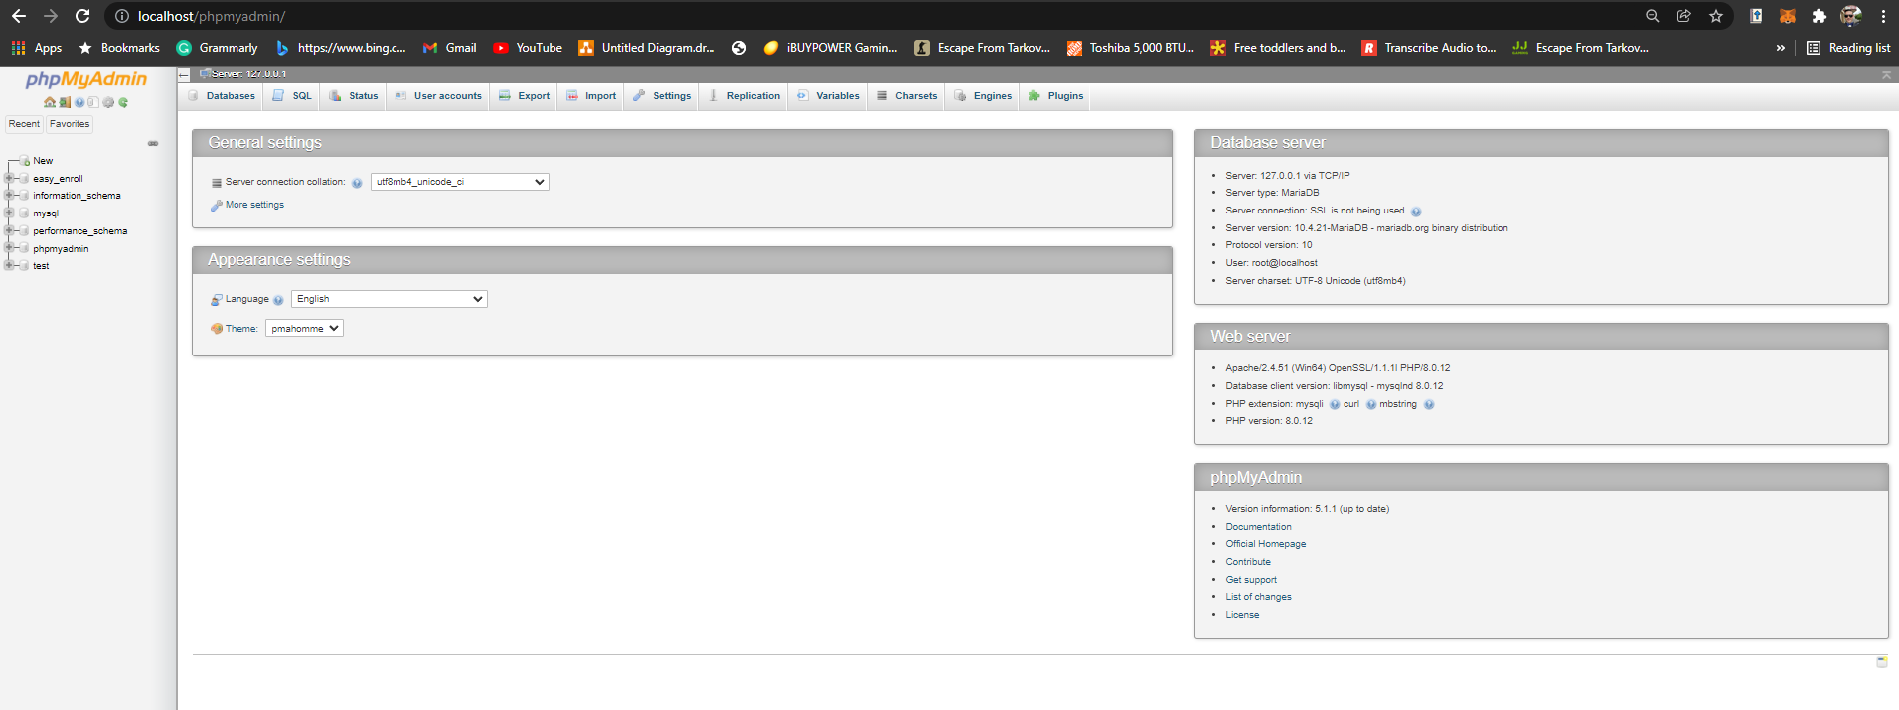

Figure 1.2 Database Overview 1

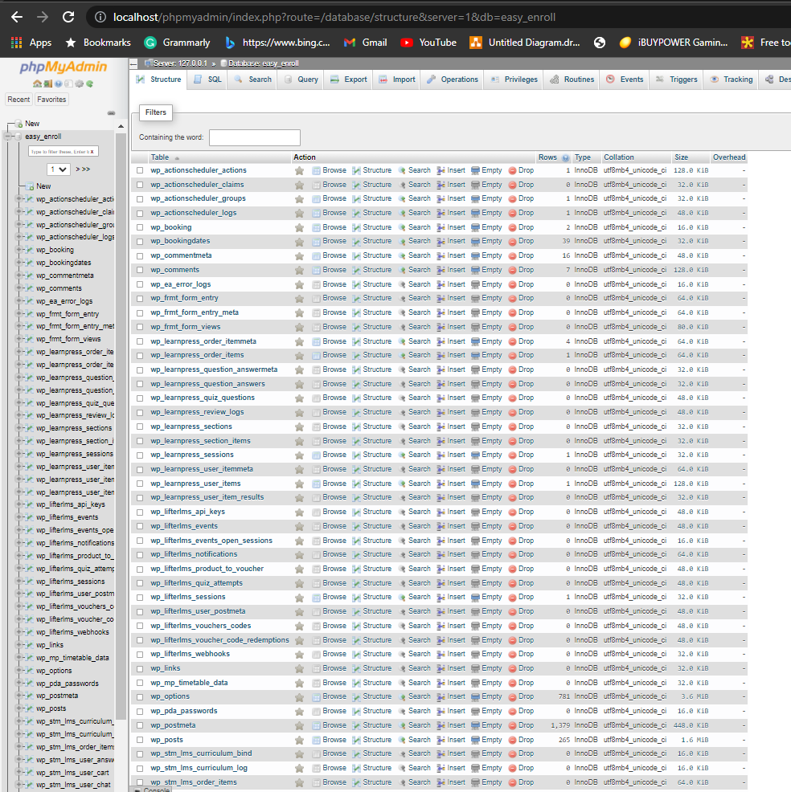

Figure 1.3 Database Overview 2

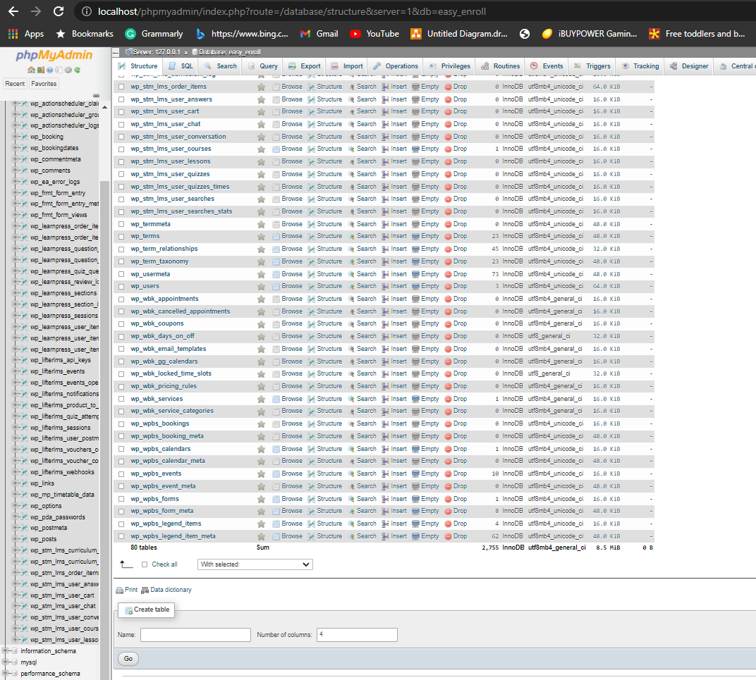

Figure 1.4 Easy Enroll Tables

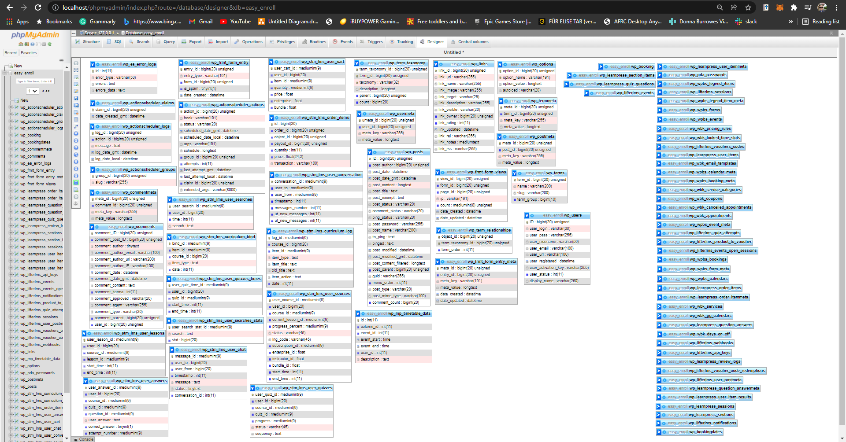

Figure 1.5 Users Table

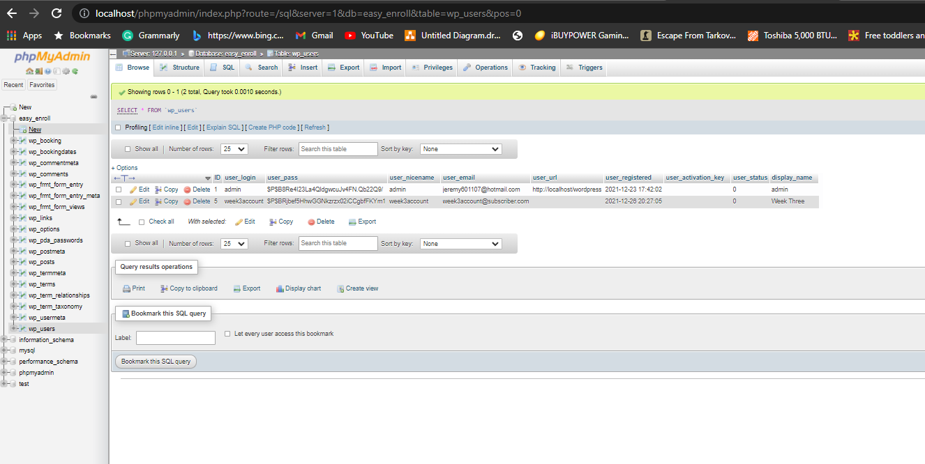

Figure 1.6 Comments Table Prior to Enrollment

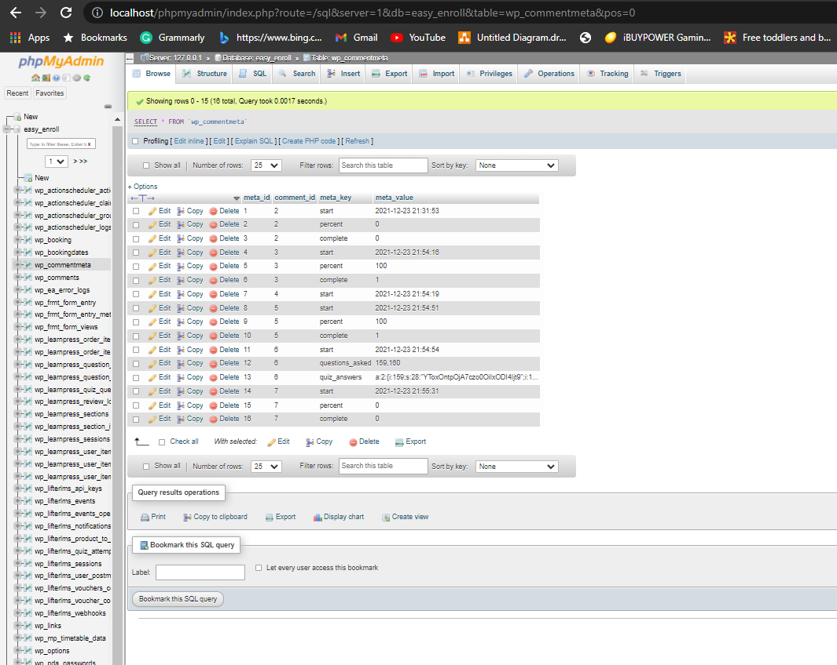

Figure 1.7 Comments Table After Student Enrollment

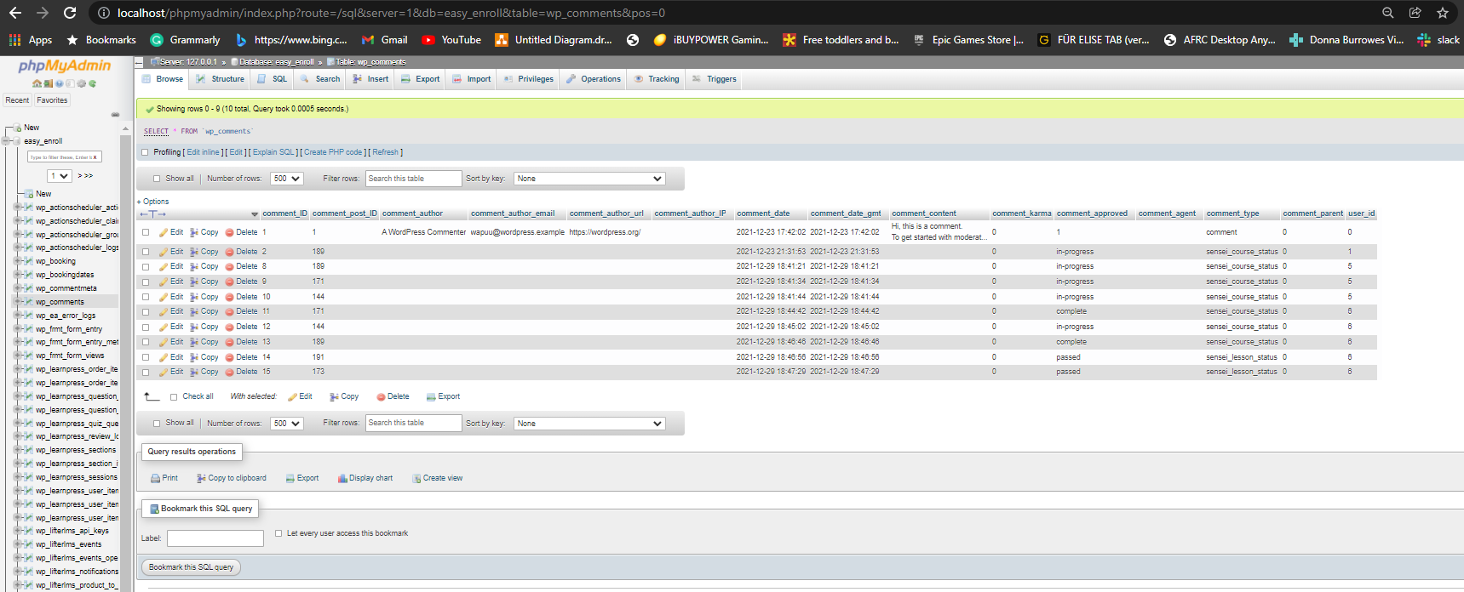

**Create the different pages related to the rest of the requirements and the design per your work in Week 1 and Week 2.** **Generate screenshots of the different pages that you created.**

Figure 2.1 Landing page

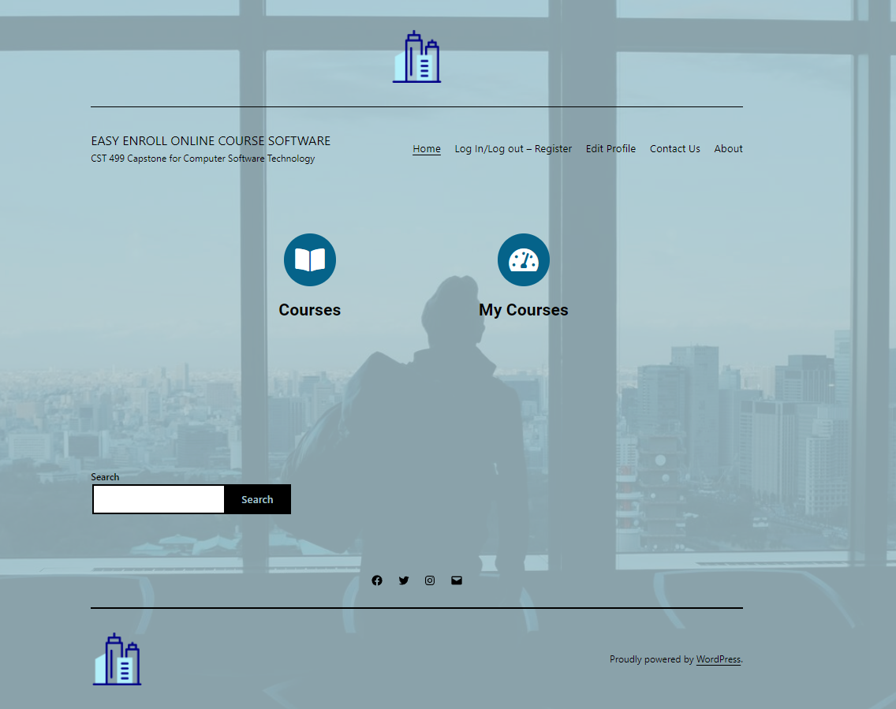

Figure 2.2 About page

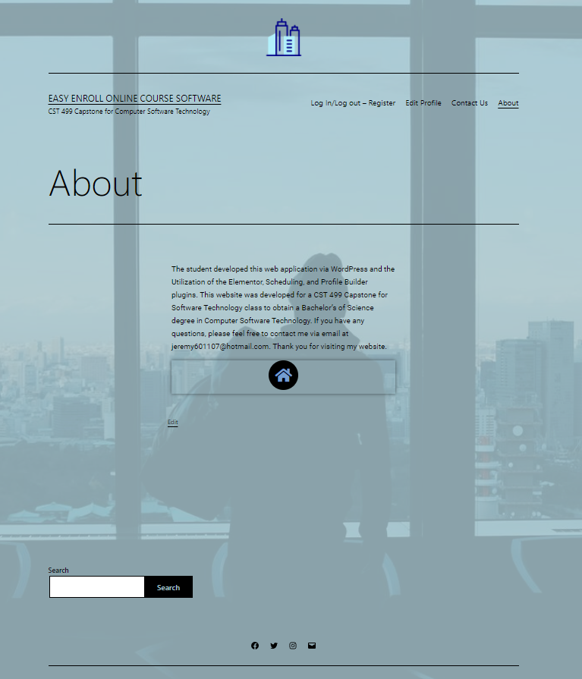

Figure 2.3 Contact Us page

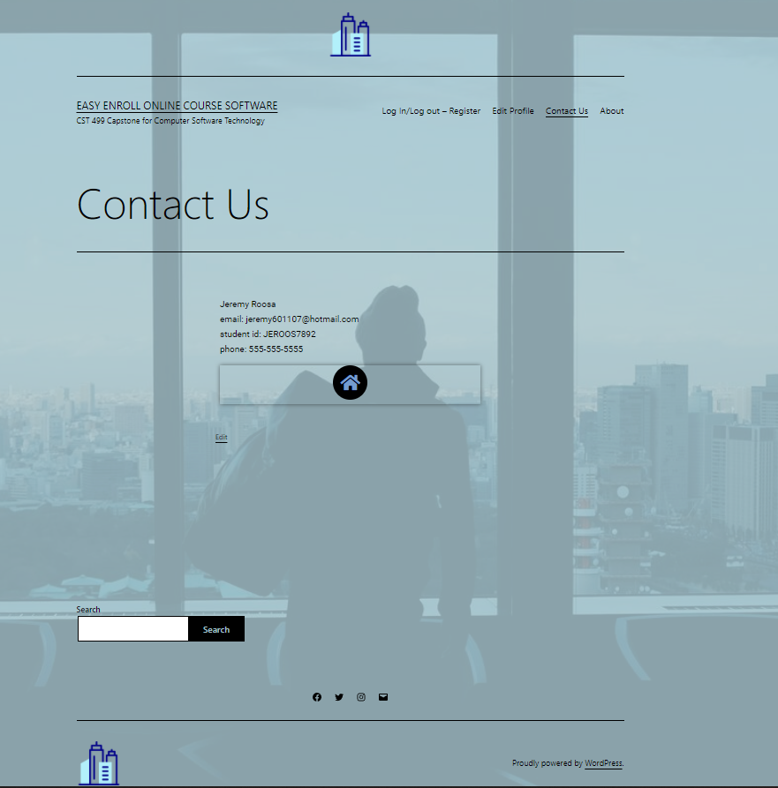

Figure 2.4 Logged-Out Page

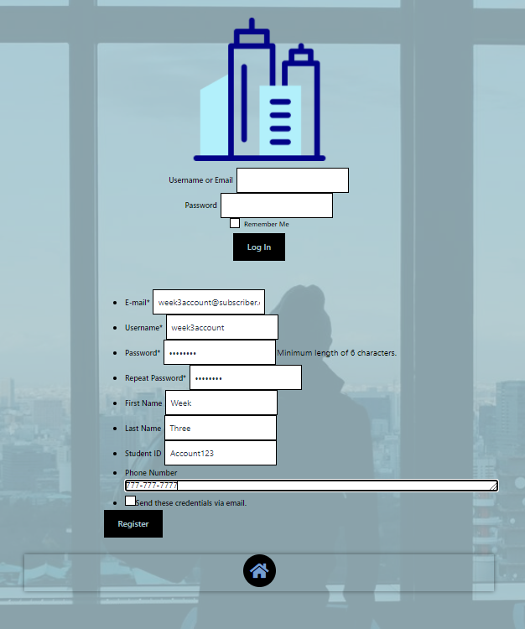

Figure 2.5 Logged-In page

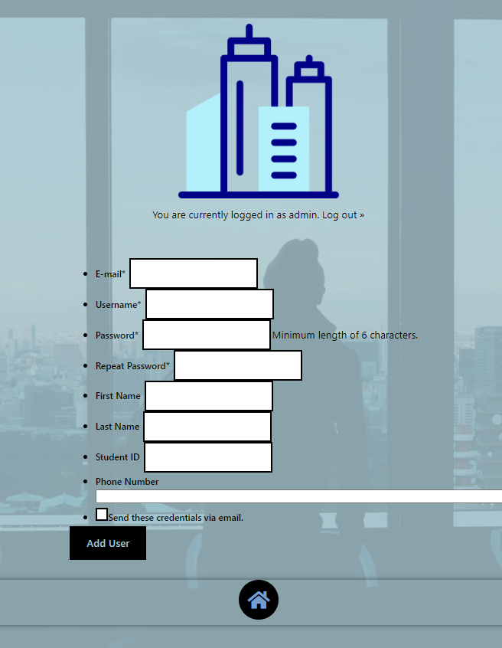

Figure 2.6 Login/Registration Page

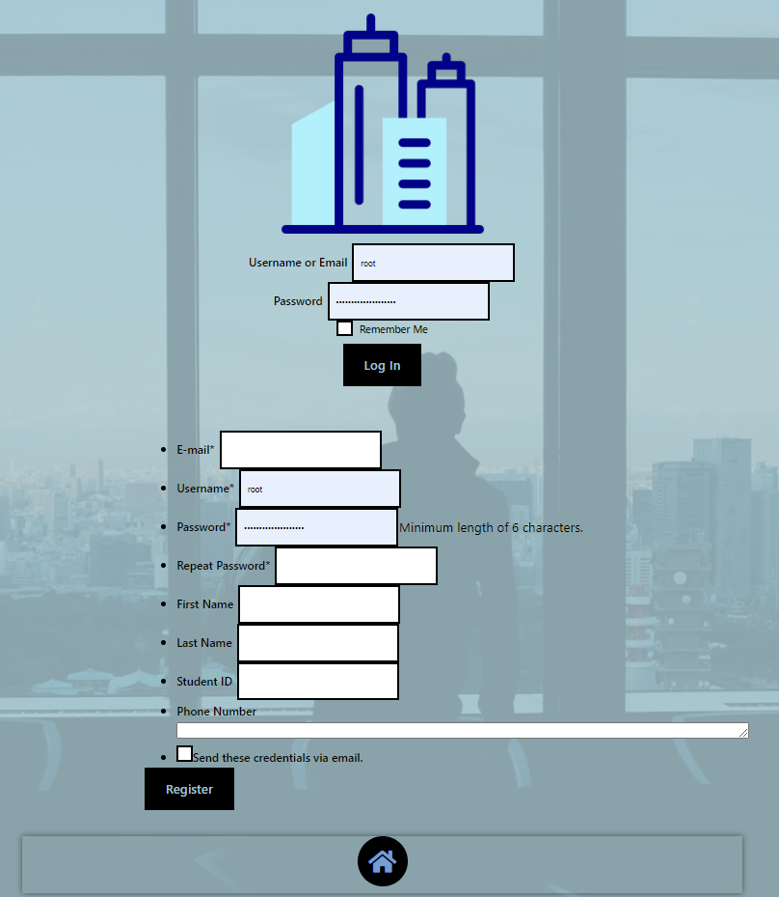

Figure 2.7 Populating Data in the Registration page

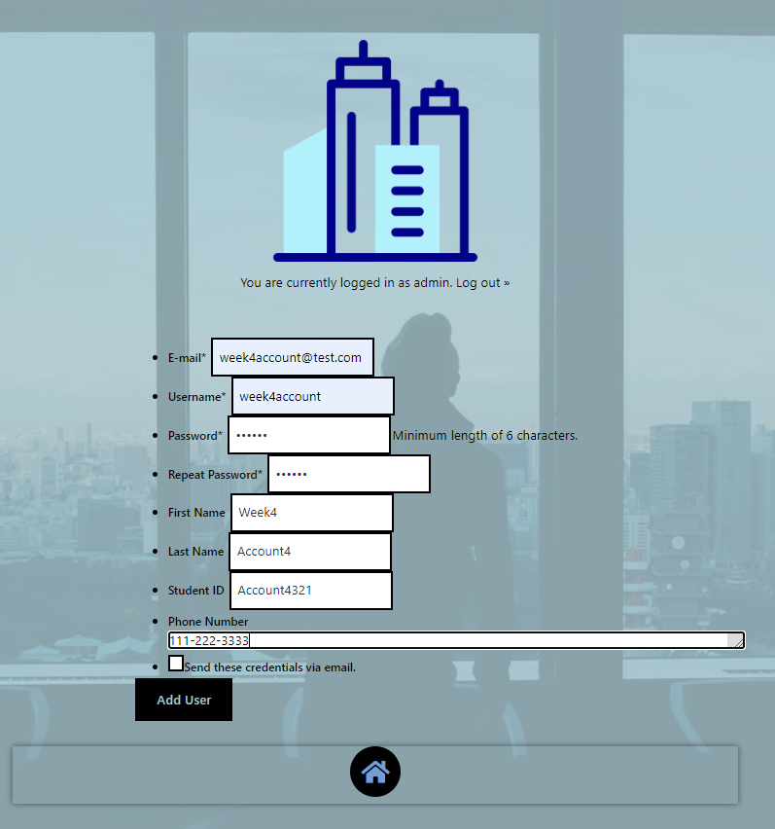

Figure 2.8 Account Creation Success page

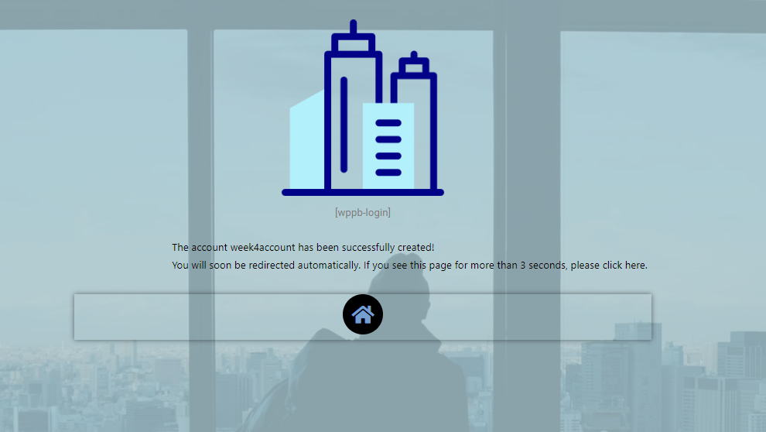

Figure 2.9 Edit Profile page

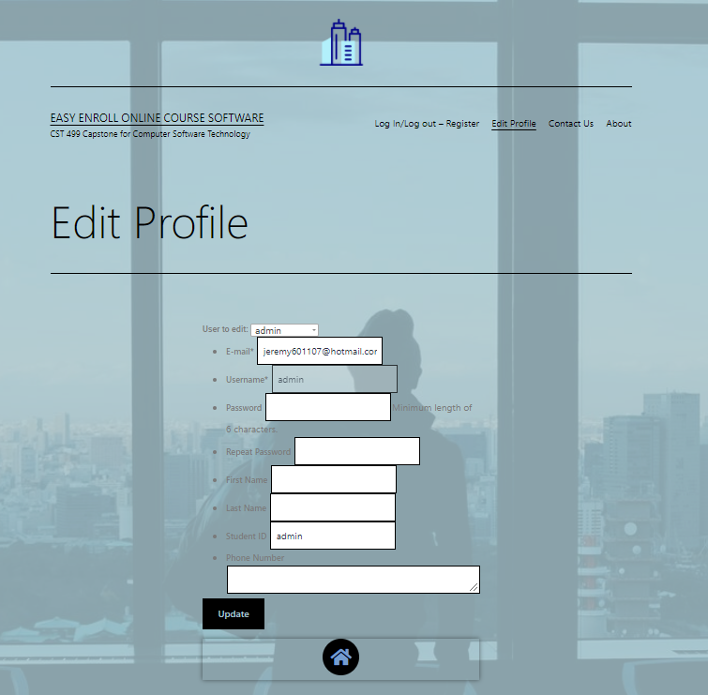

Figure 2.10 Courses Page Prior to Registering



Figure 2.11 Registering for CYB 300

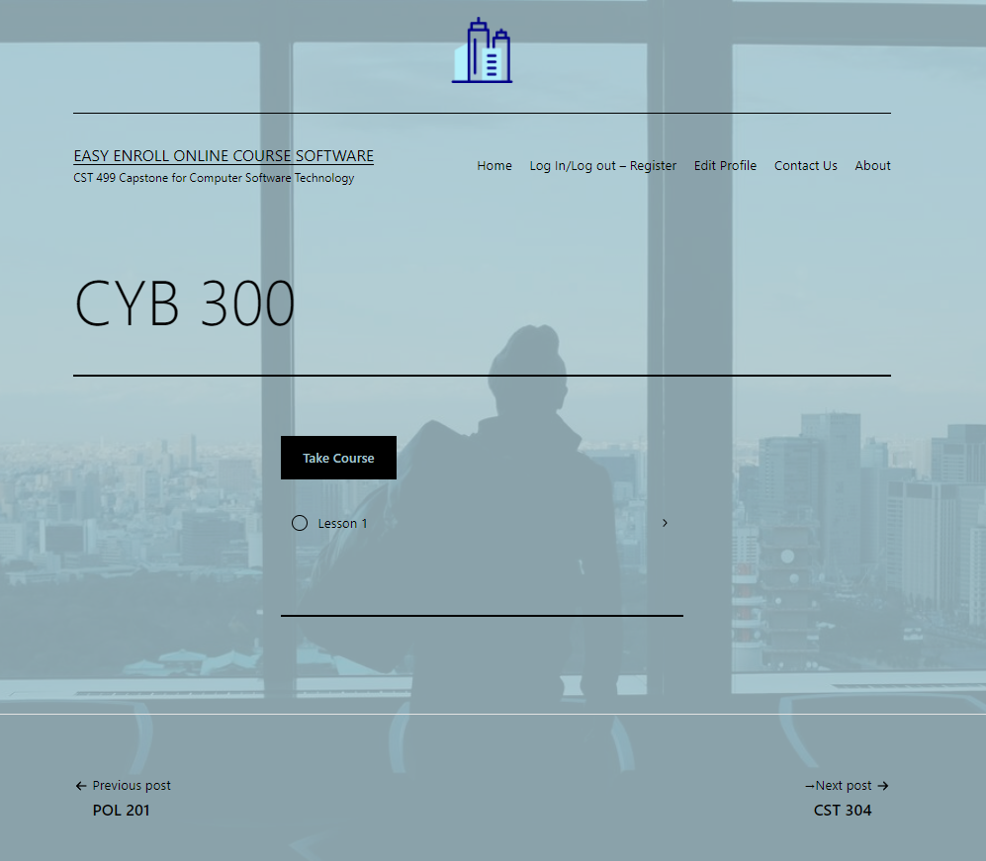

Figure 2.12 Registering for POL 201



Figure 2.13 CYB 300 in Progress

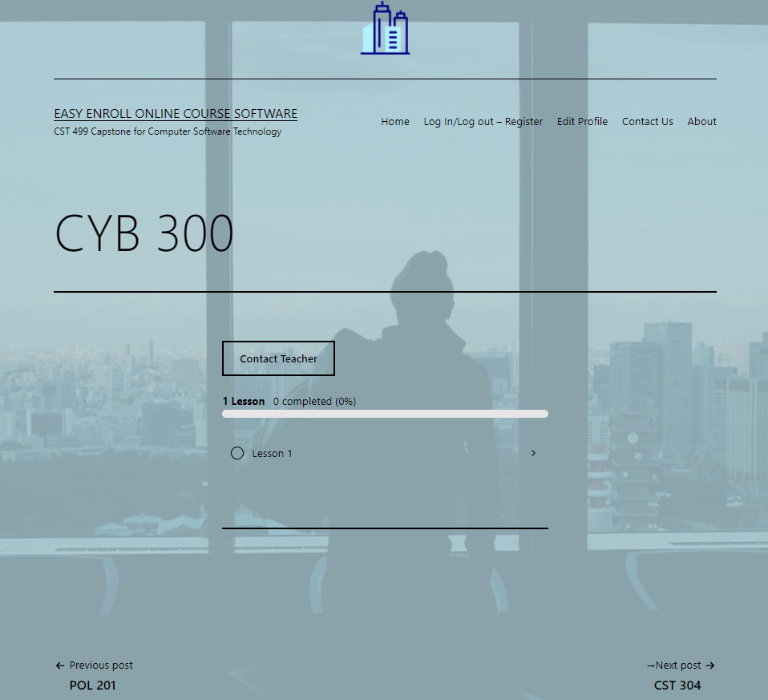

Figure 2.14 POL 201 in Progress

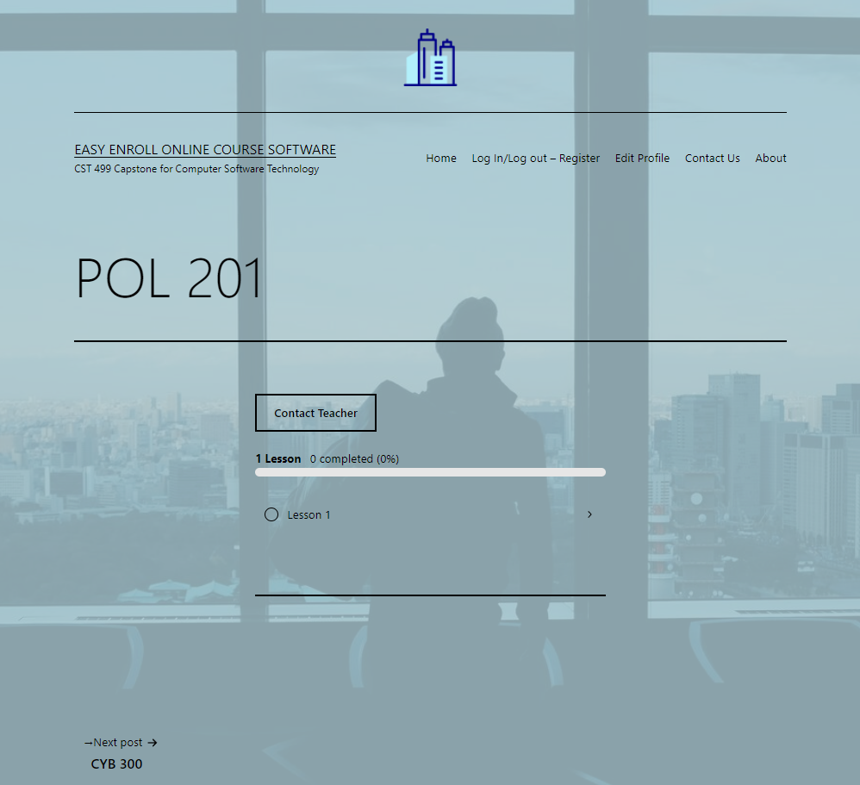

**Generate screenshots of the PHP code to implement your logic.**

Figure 3.1 Login PHP Code 1

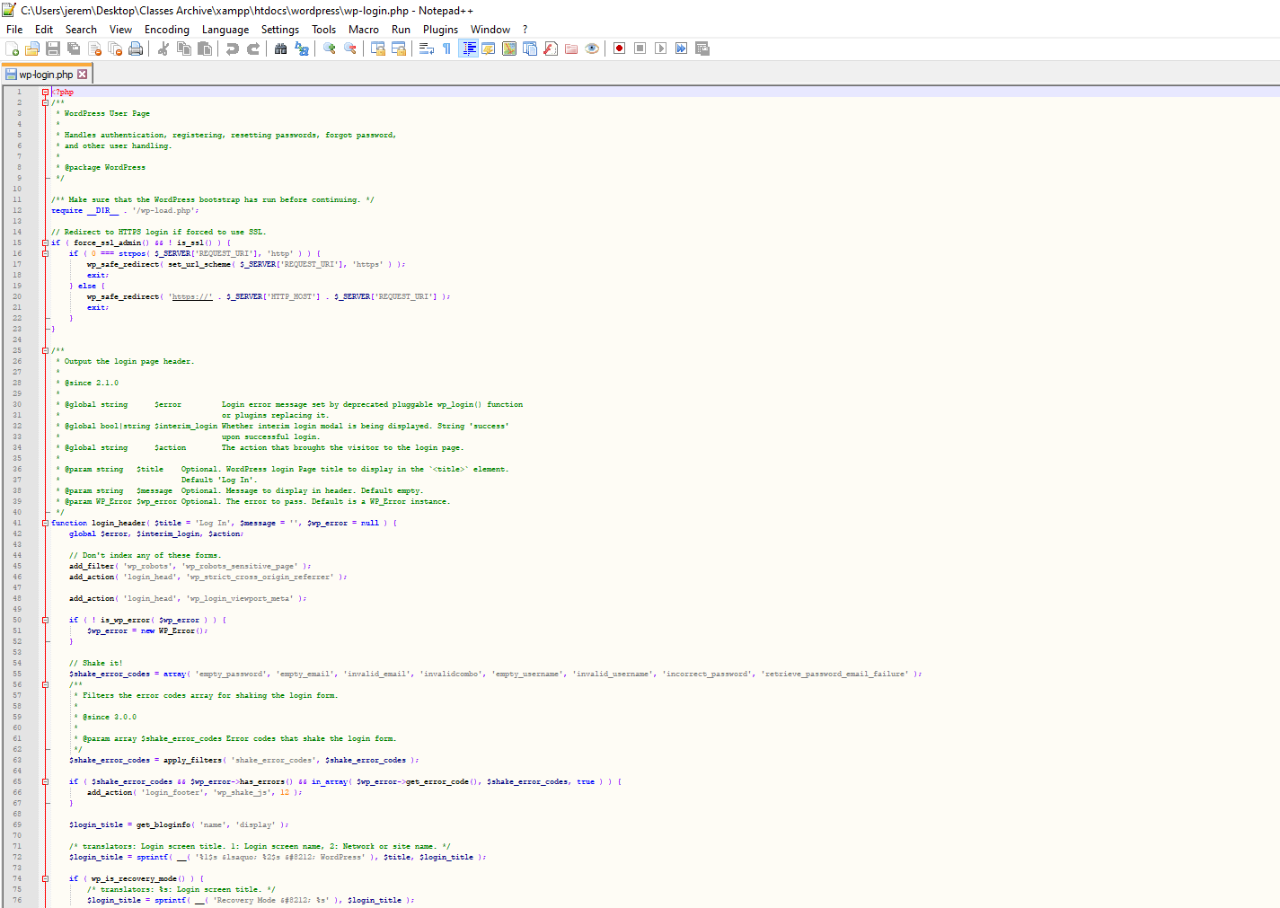

Figure 3.2 Login PHP Code 2

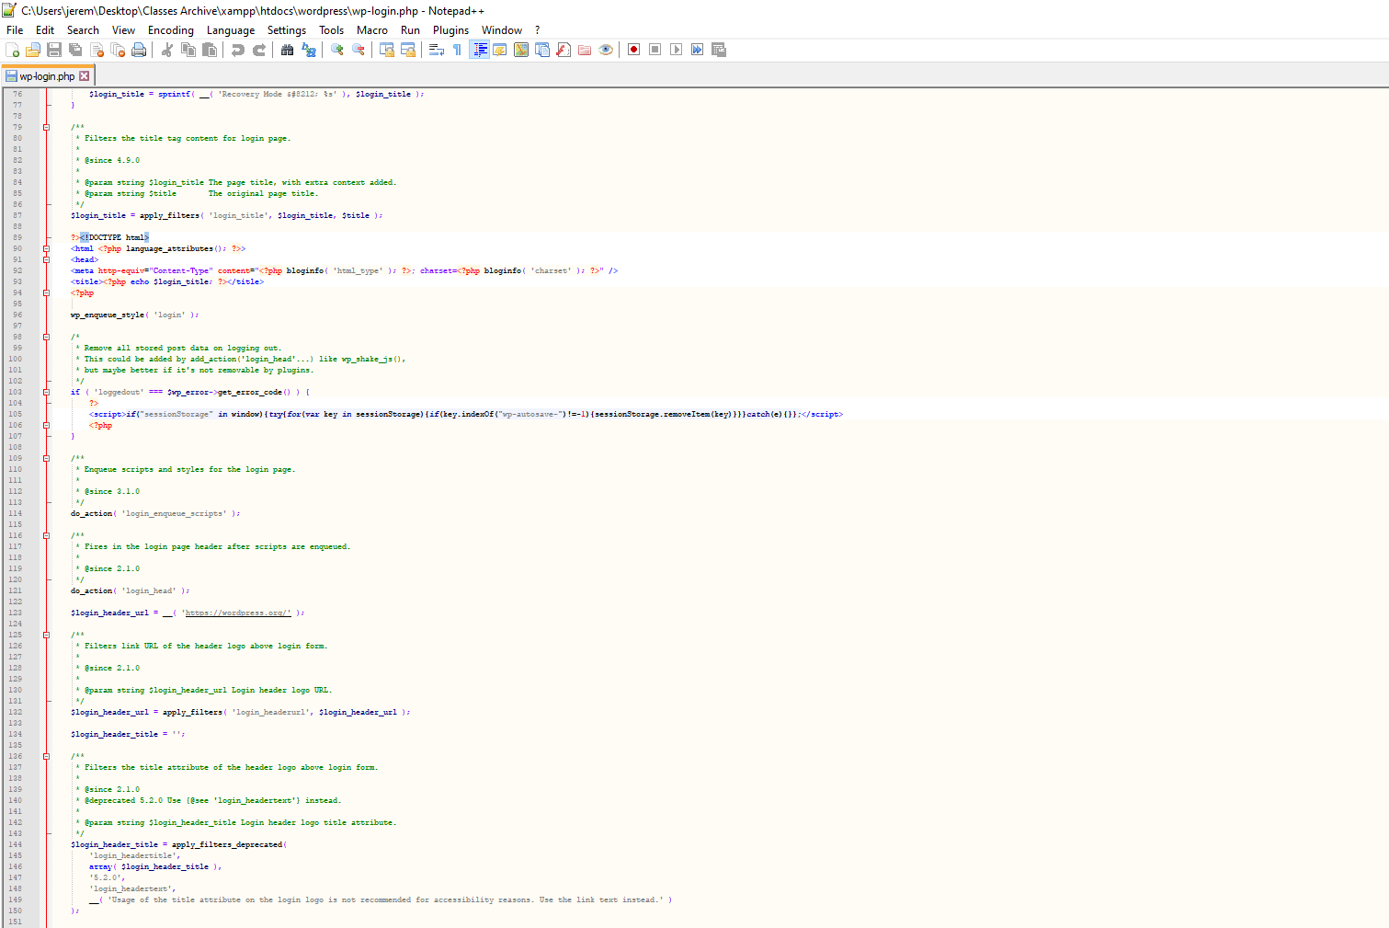

Figure 3.3 Login PHP Code 3

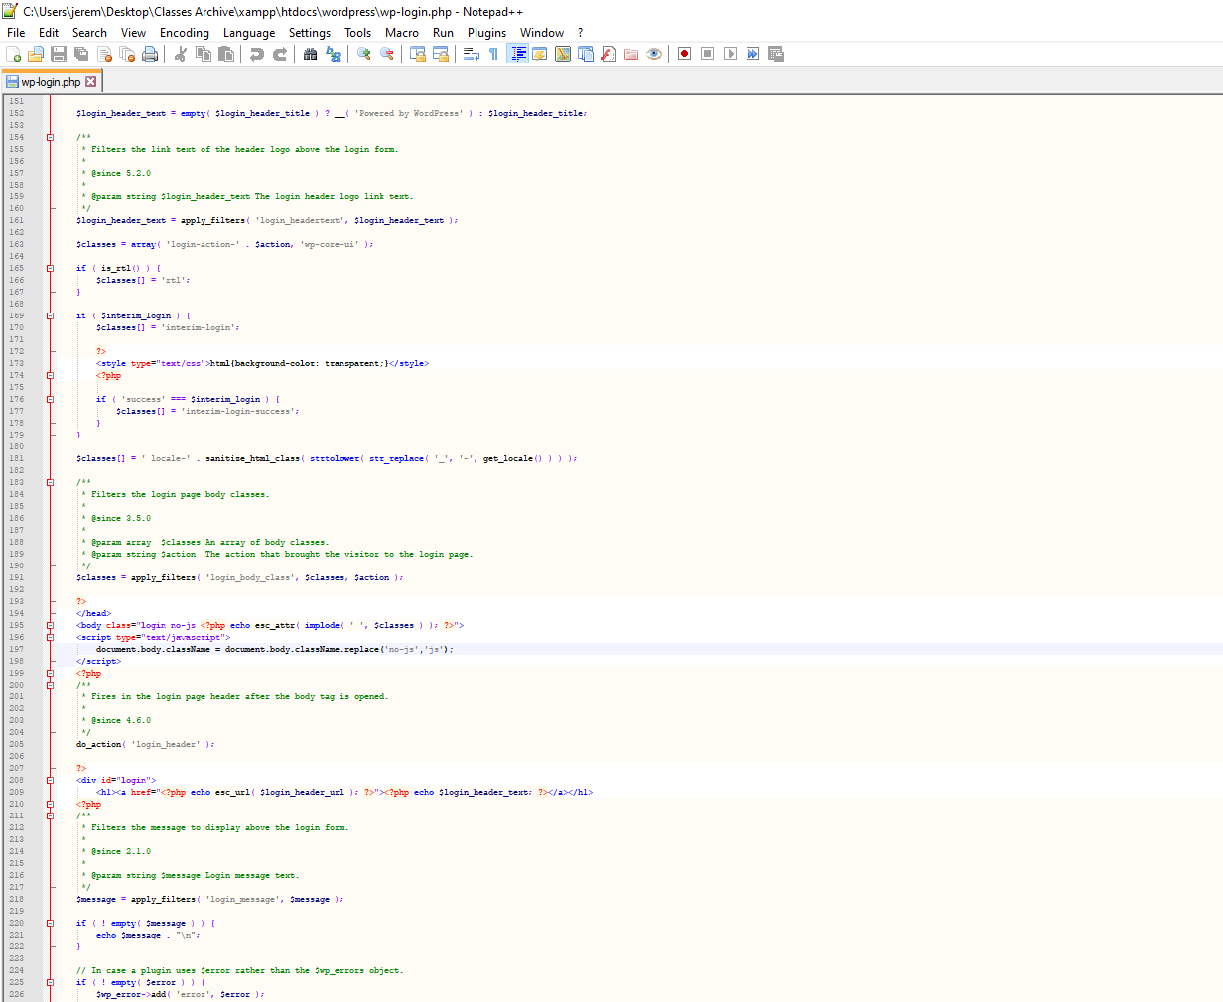

Figure 3.4 Login PHP Code 4

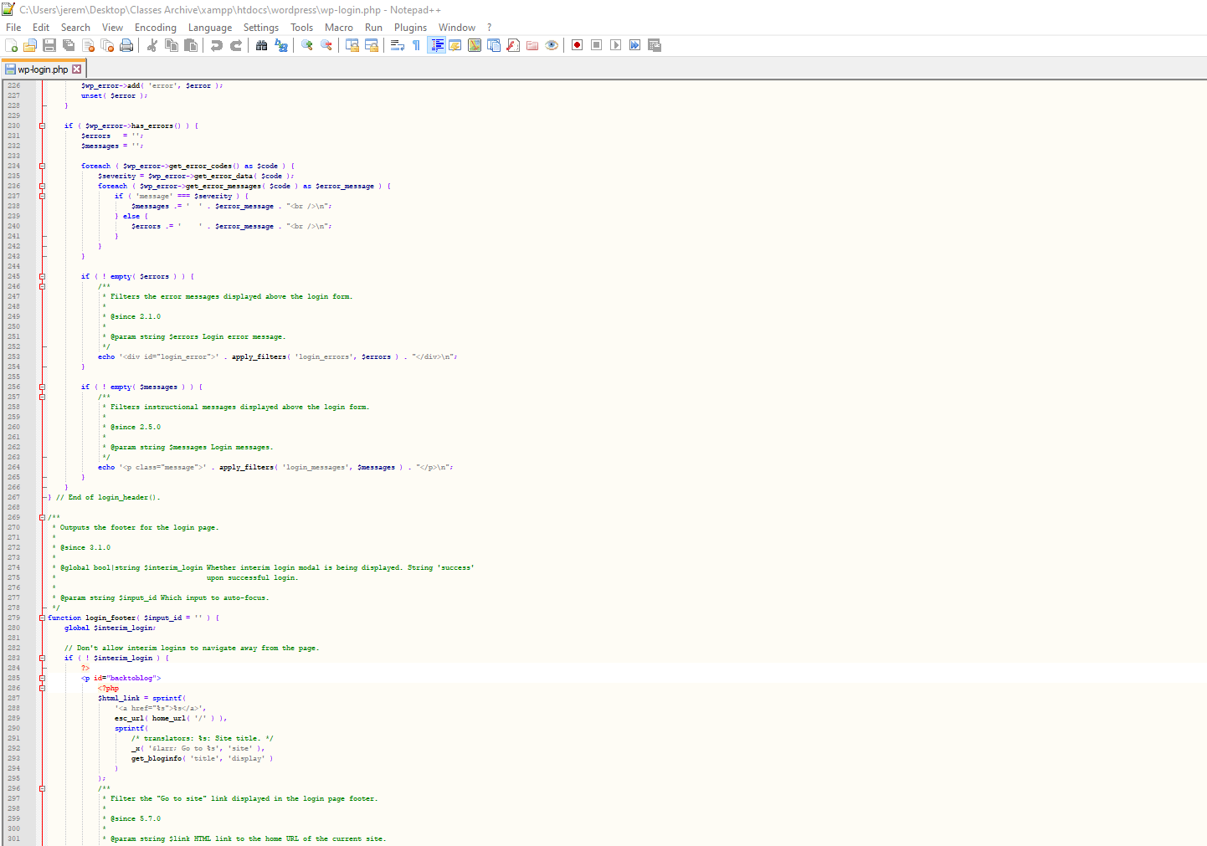

Figure 3.5 Login PHP Code 5

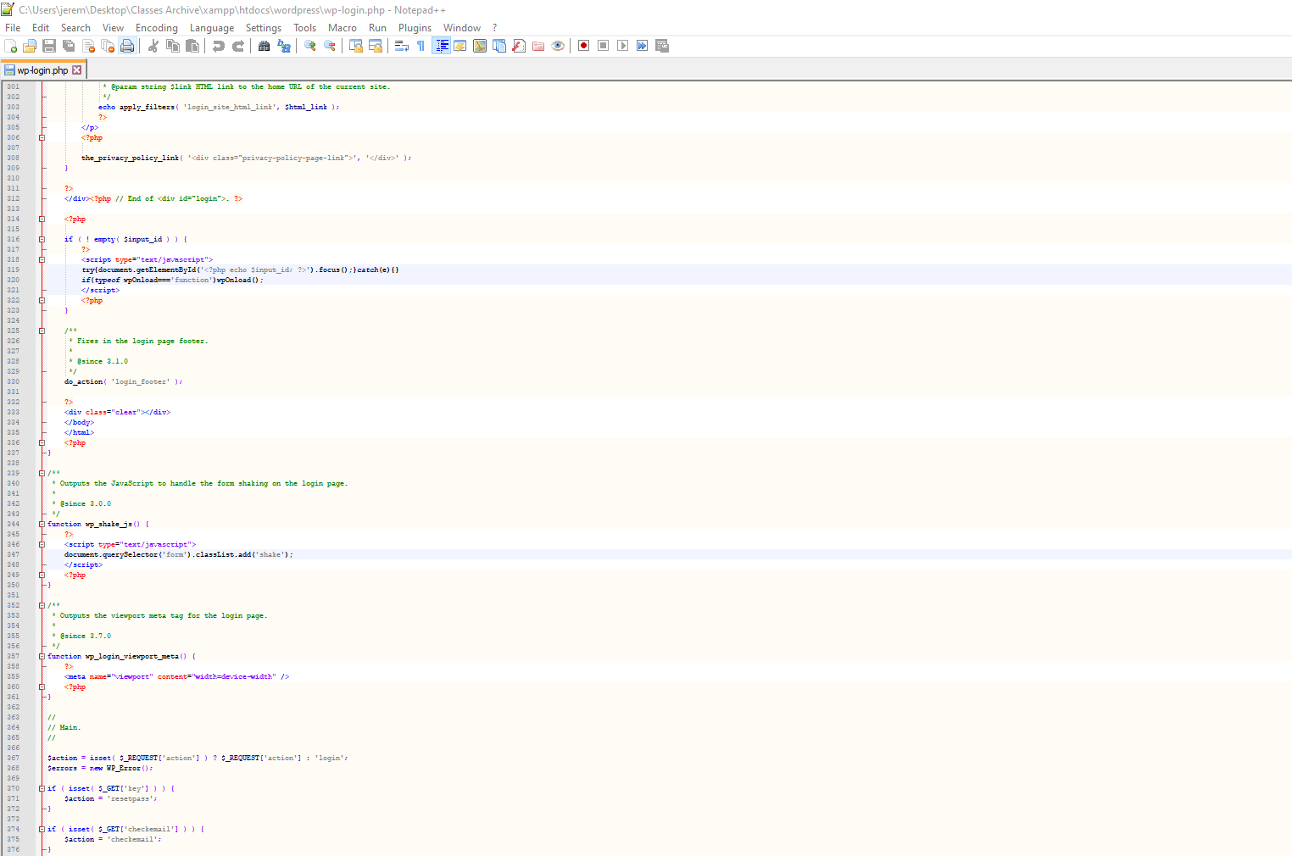

Figure 3.6 Login PHP Code 6

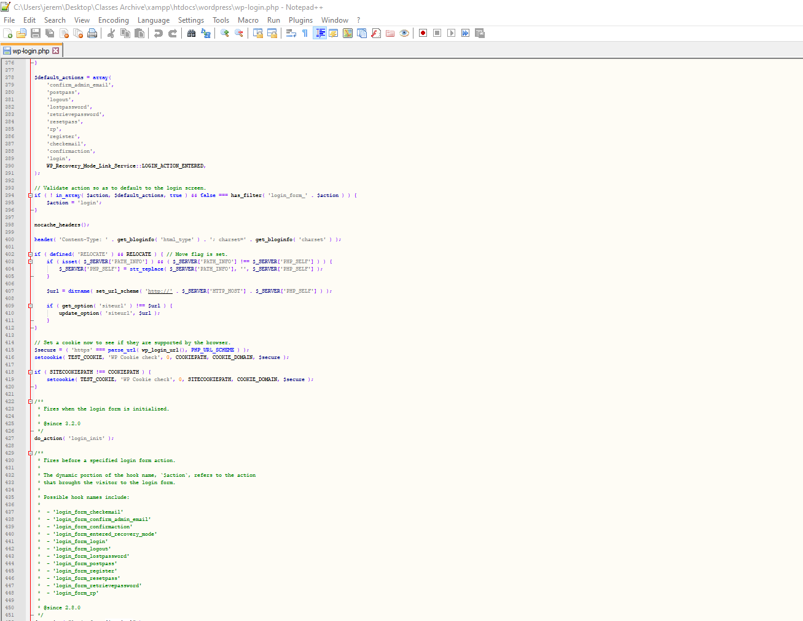

Figure 3.7 Login PHP Code 7

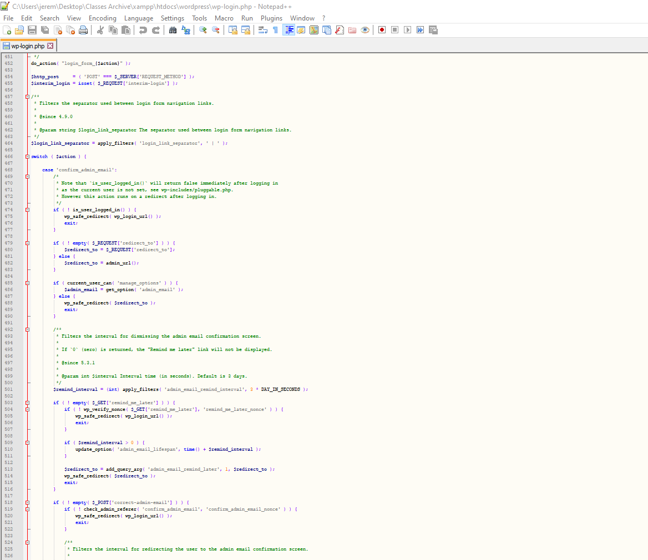

Figure 3.8 Login PHP Code 8

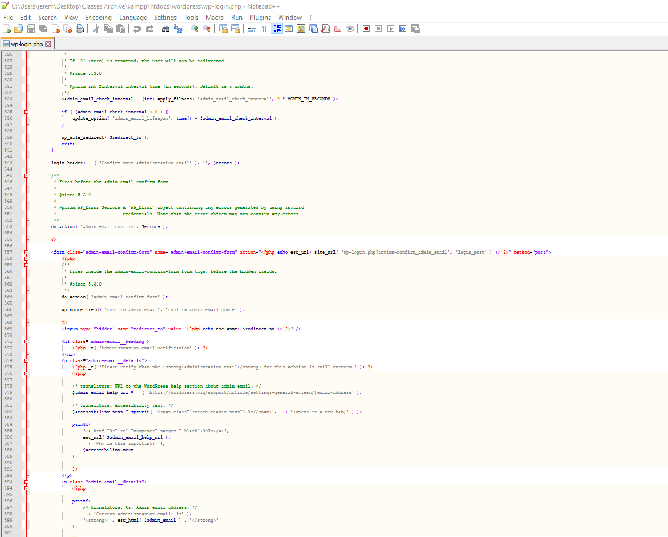

Figure 3.9 Login PHP Code 9

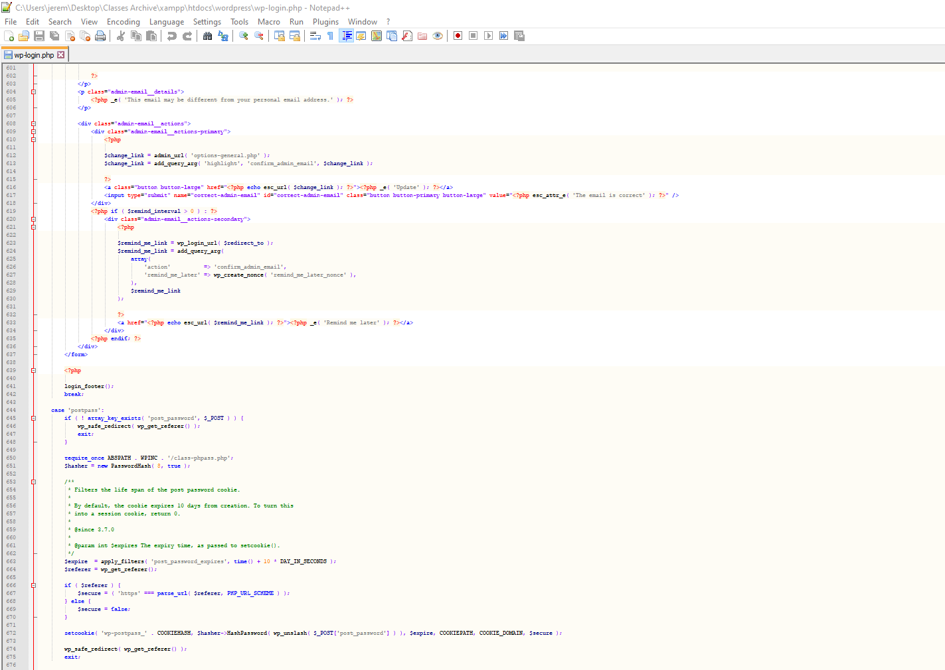

Figure 3.10 Login PHP Code 10

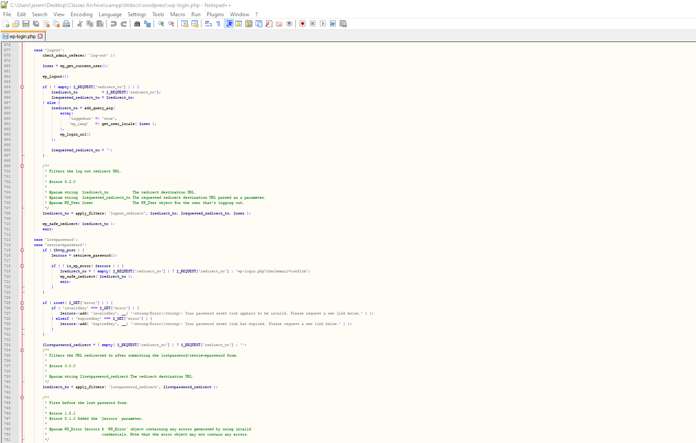

Figure 3.11 Login PHP Code 11

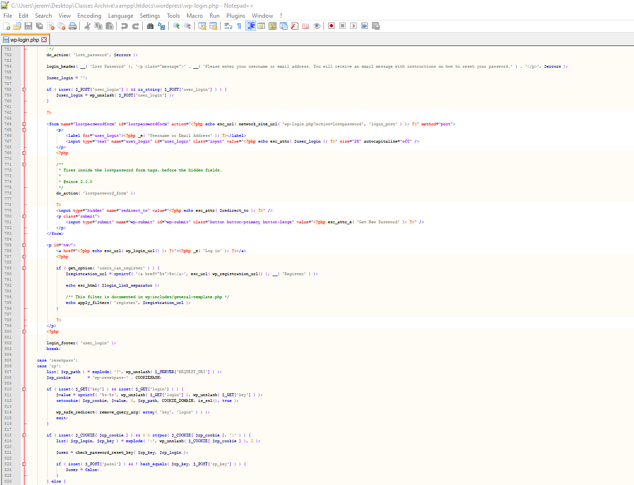

Figure 3.12 Login PHP Code 12

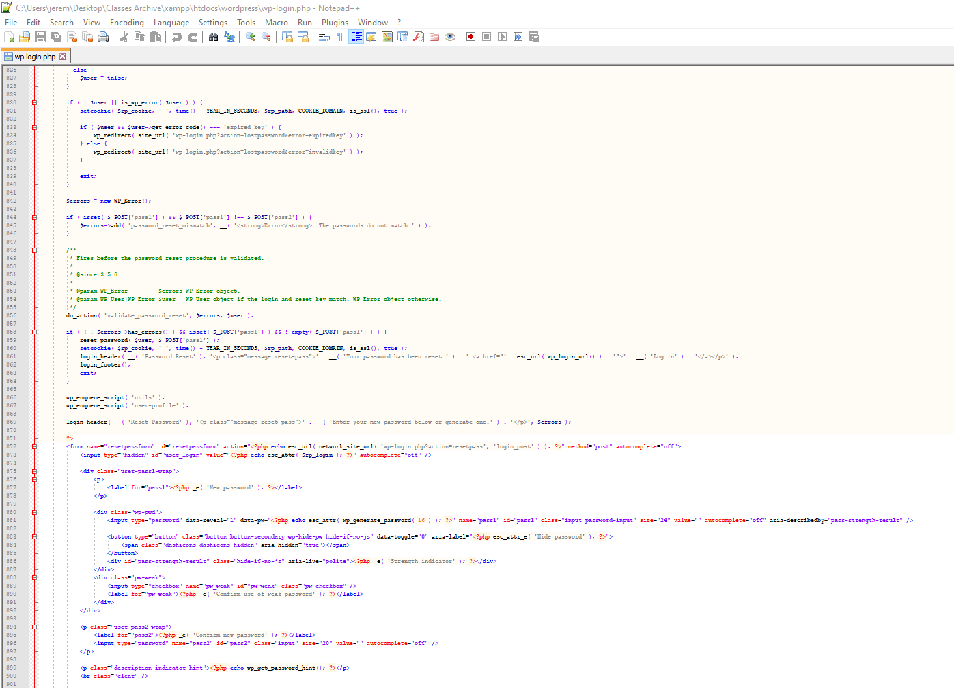

Figure 3.13 Login PHP Code 13

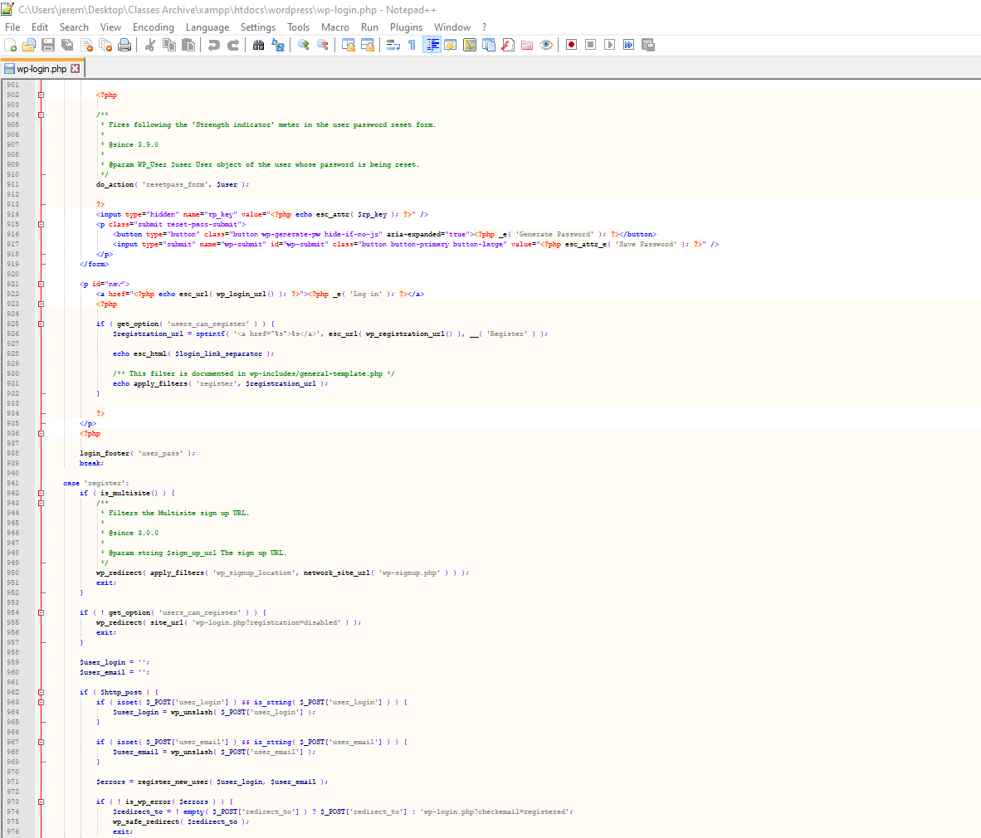

Figure 3.14 Login PHP Code 14

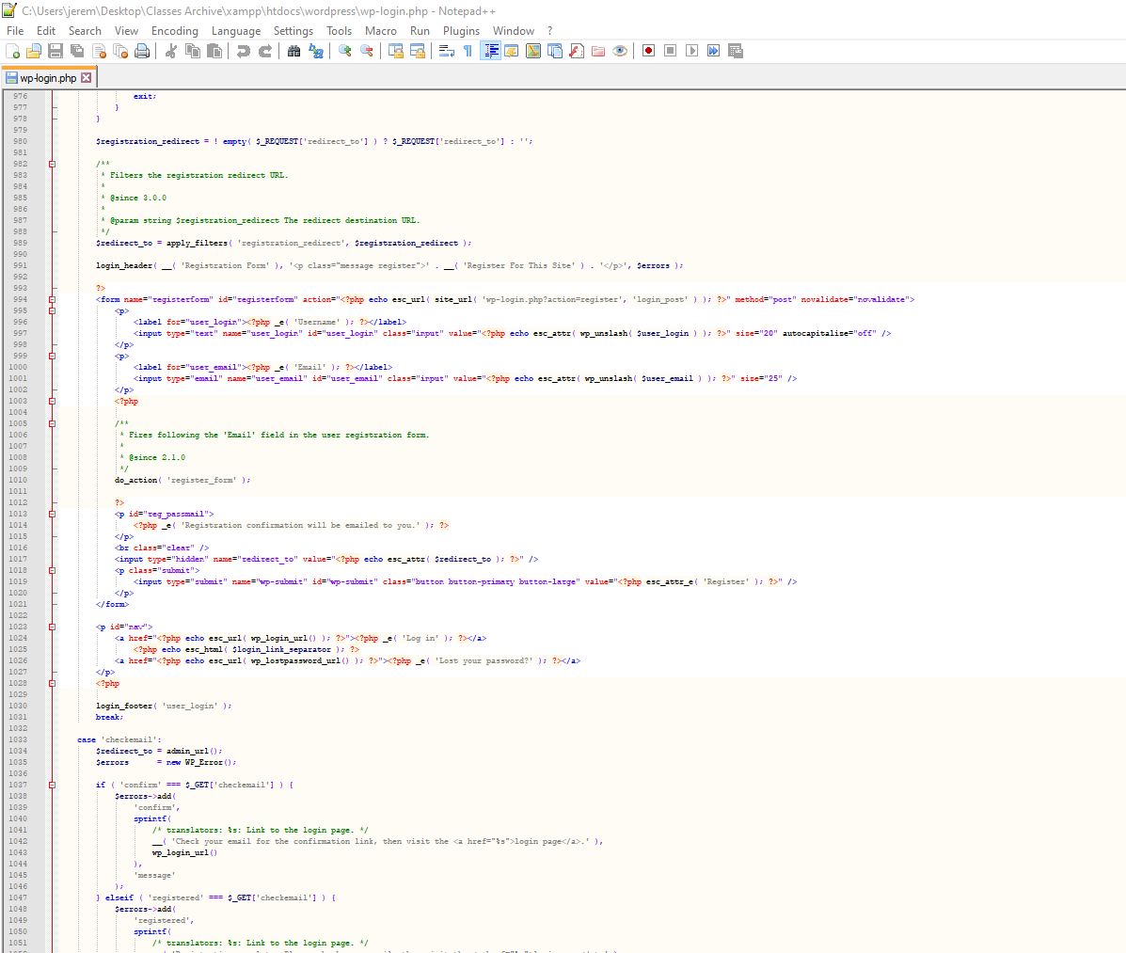

Figure 3.15 Login PHP Code 15

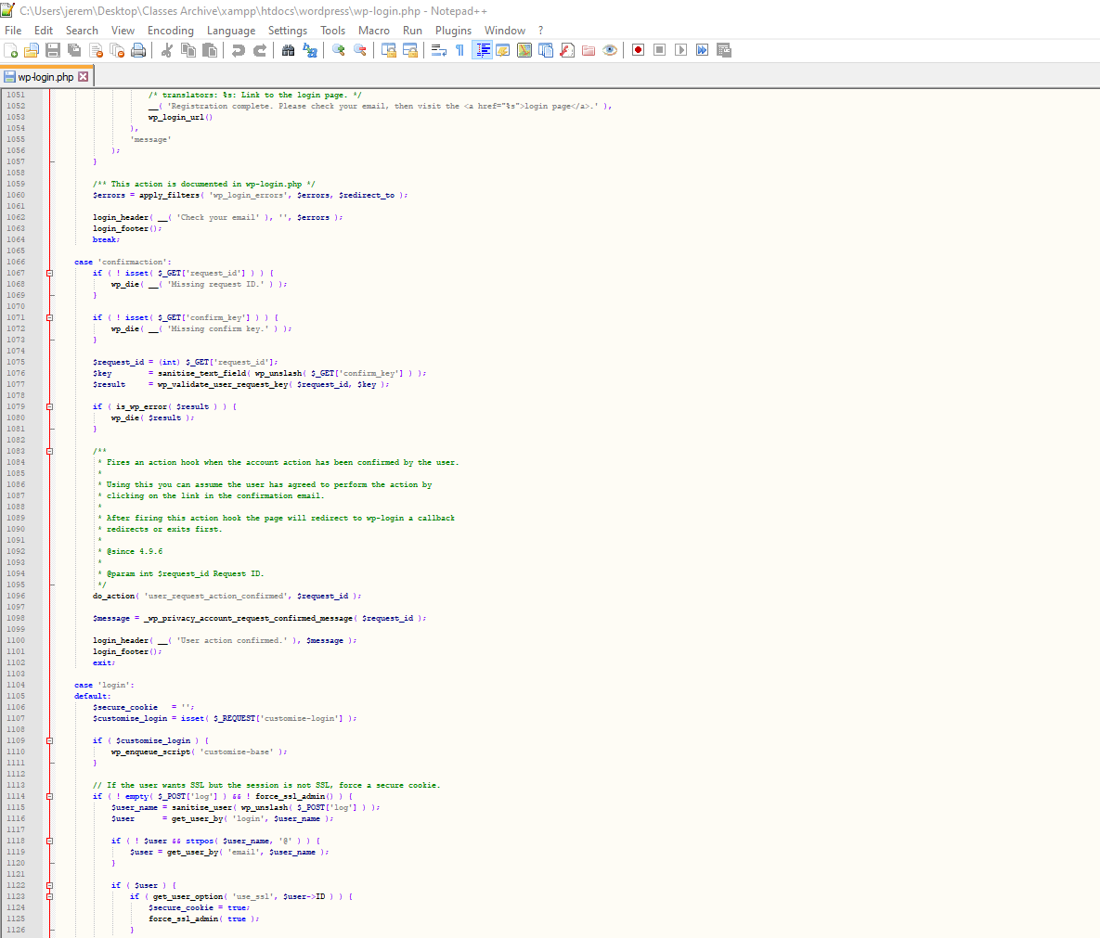

Figure 3.16 Login PHP Code 16

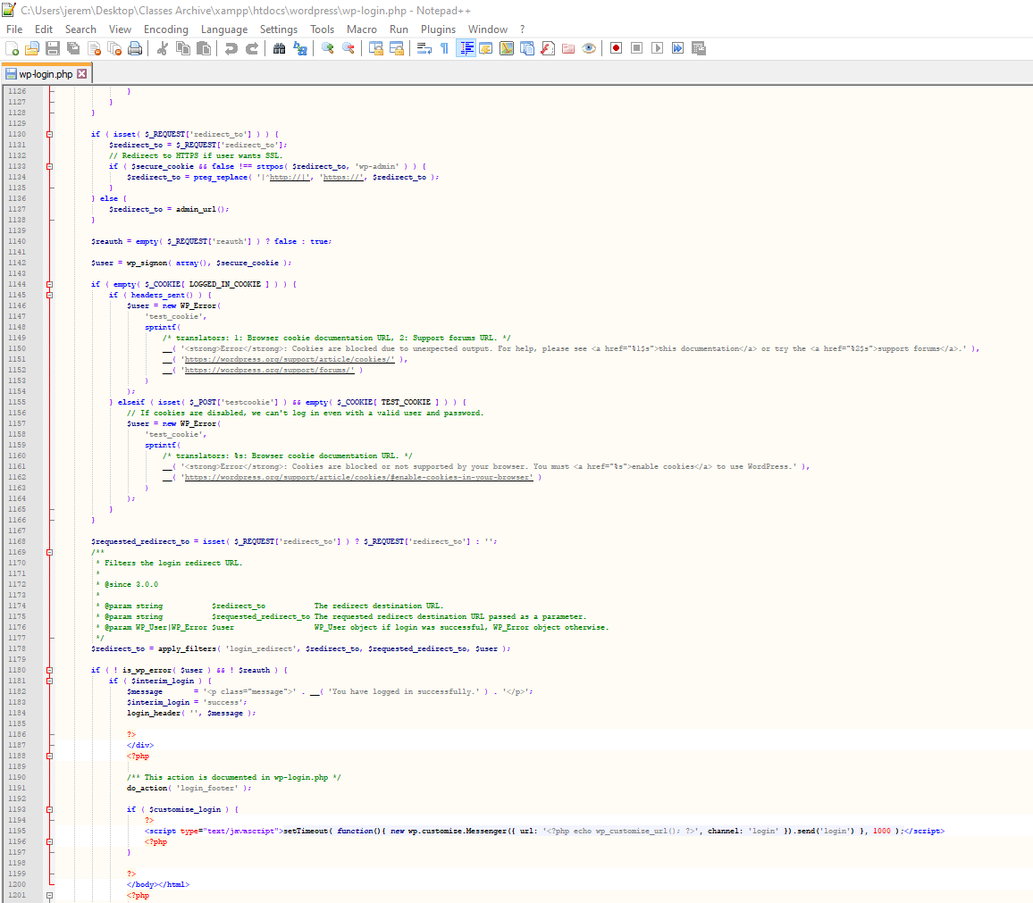

Figure 3.17 Login PHP Code 17

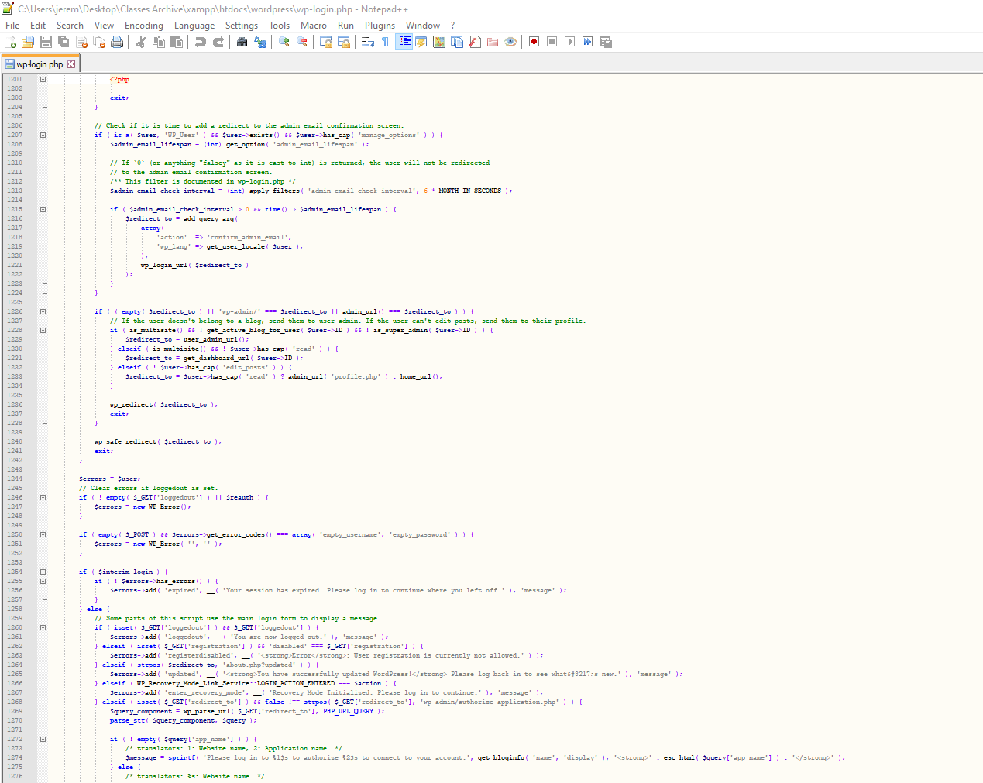

Figure 3.18 Login PHP Code 18

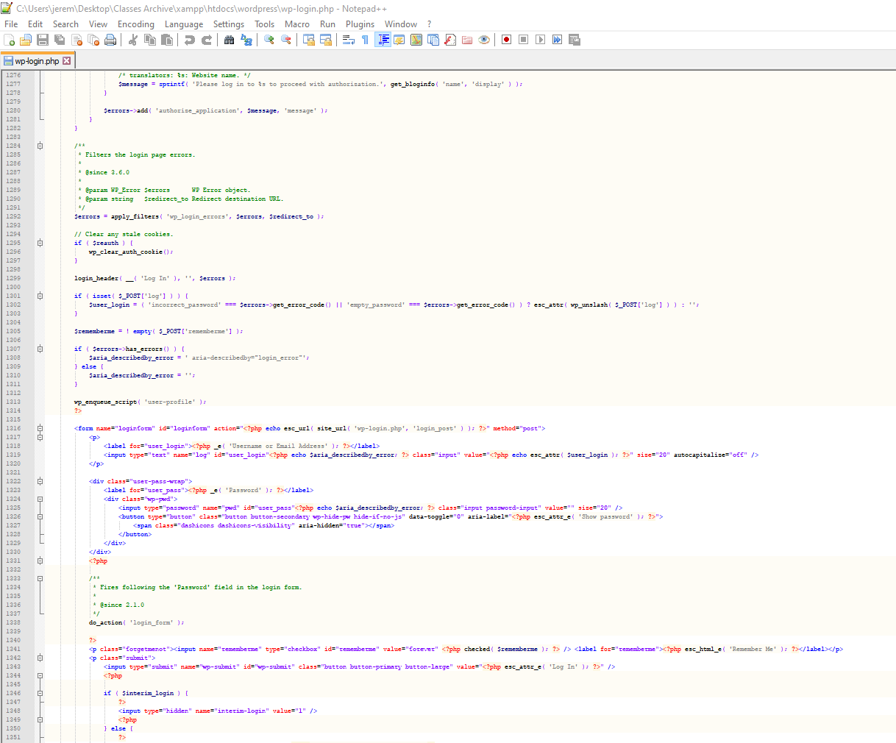

Figure 3.19 Login PHP Code 19

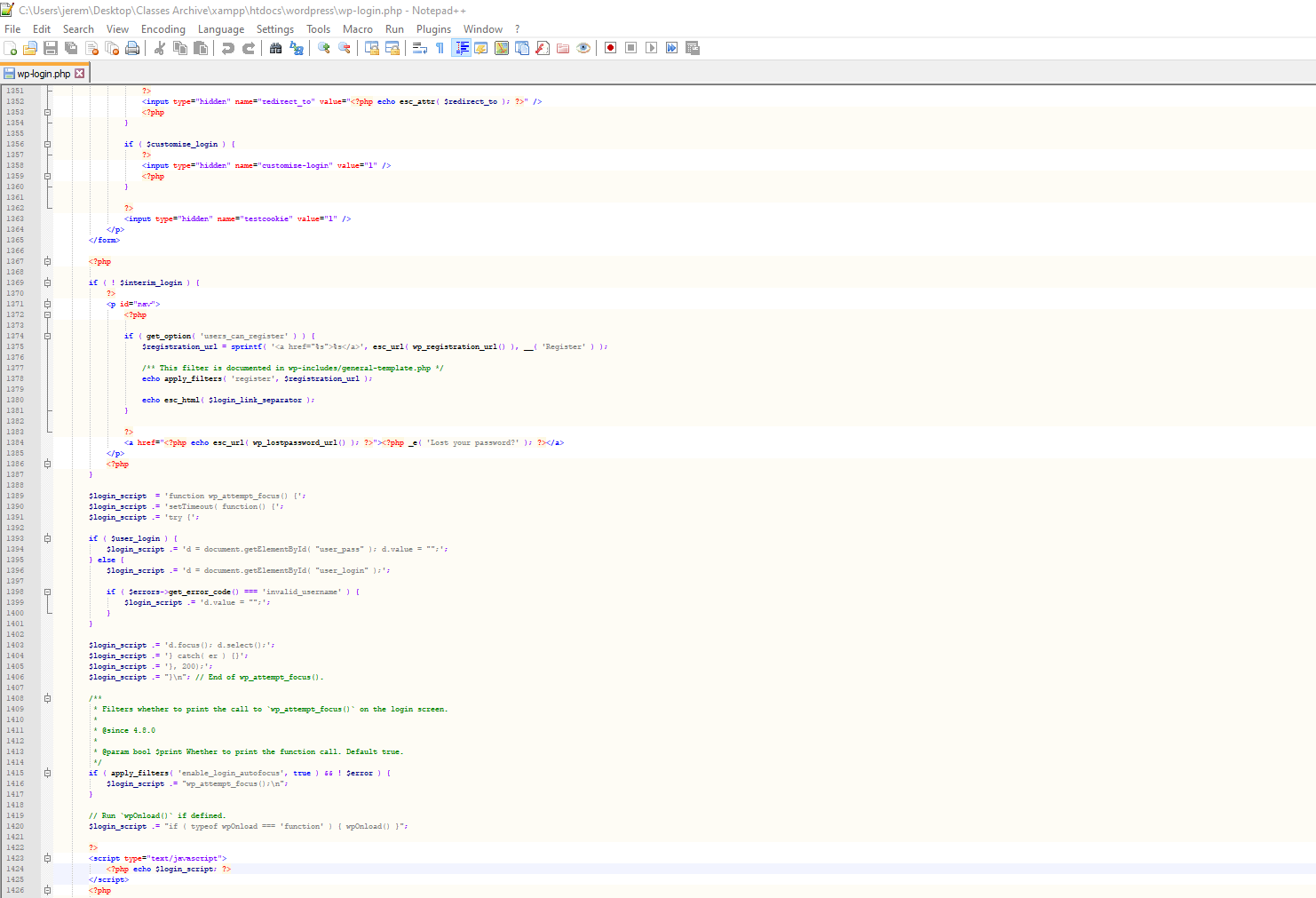

Figure 3.20 Login PHP Code 20

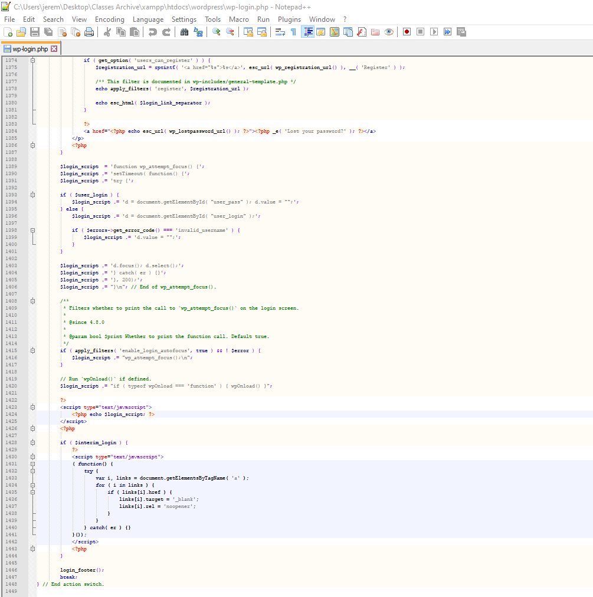

Figure 4.1 Registration PHP code 1

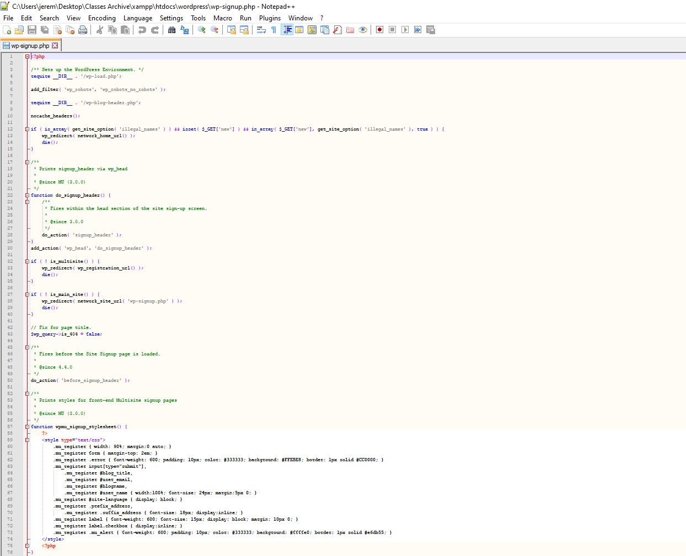

Figure 4.2 Registration PHP code 2

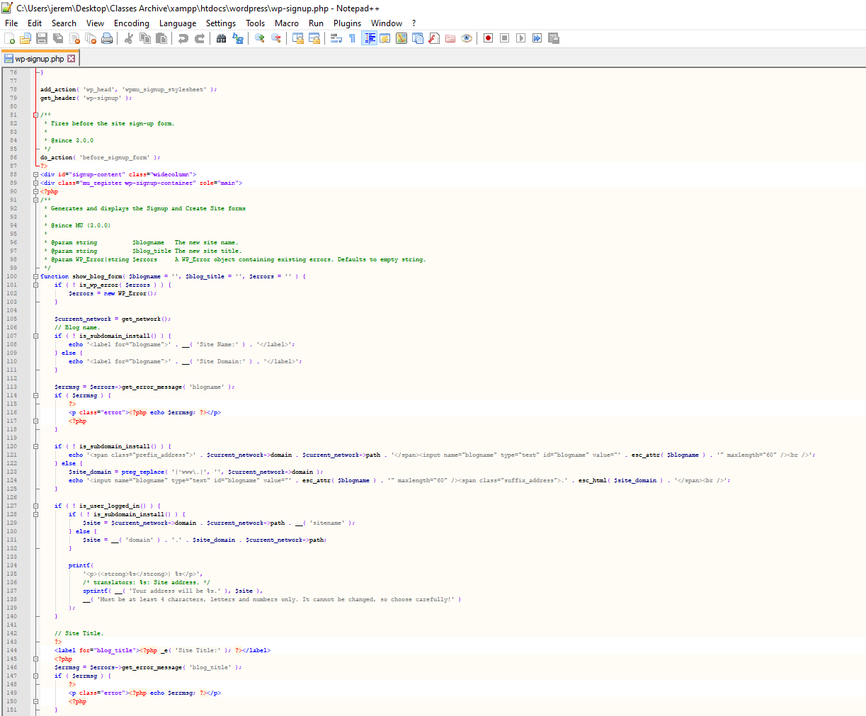

Figure 4.3 Registration PHP code 3

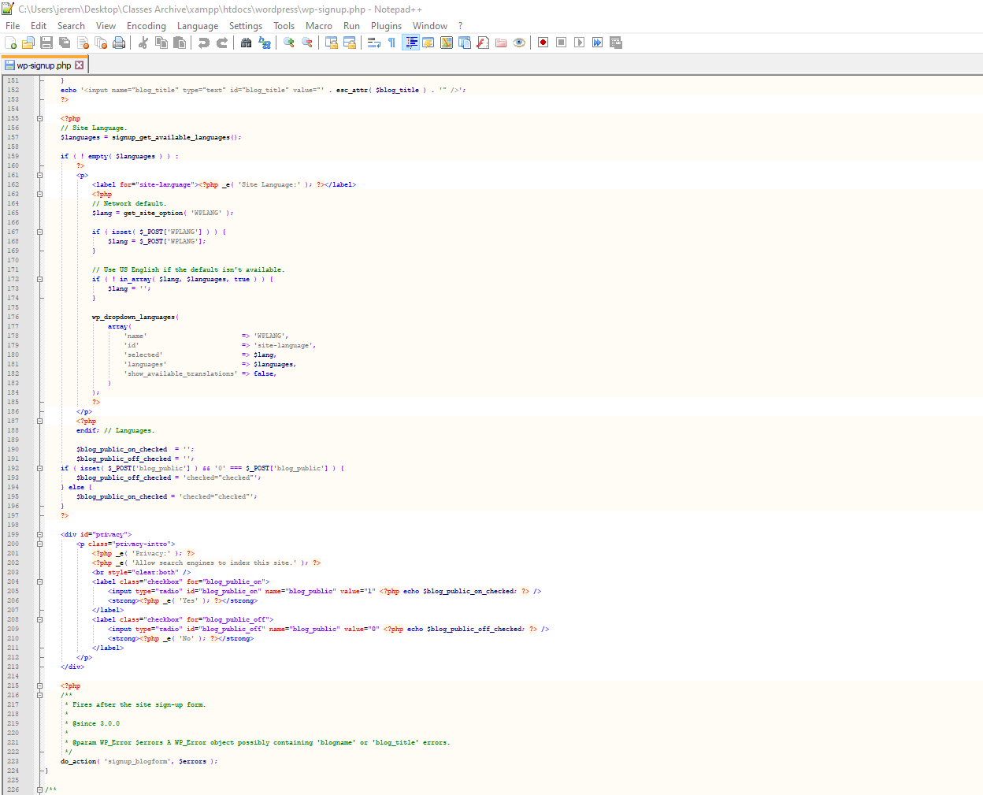

Figure 4.4 Registration PHP code 4

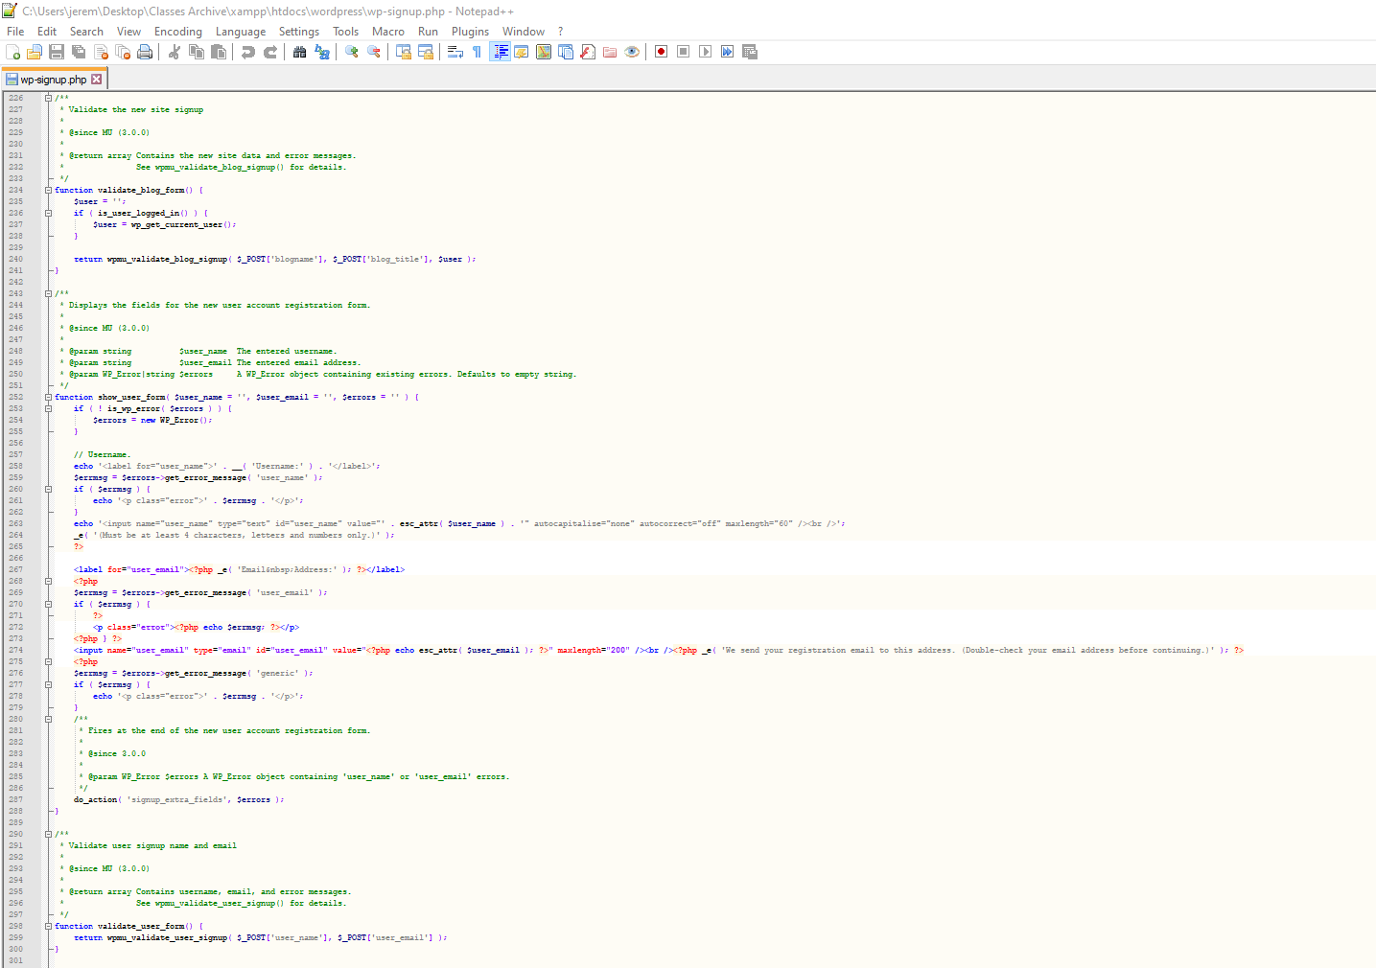

Figure 4.5 Registration PHP code 5

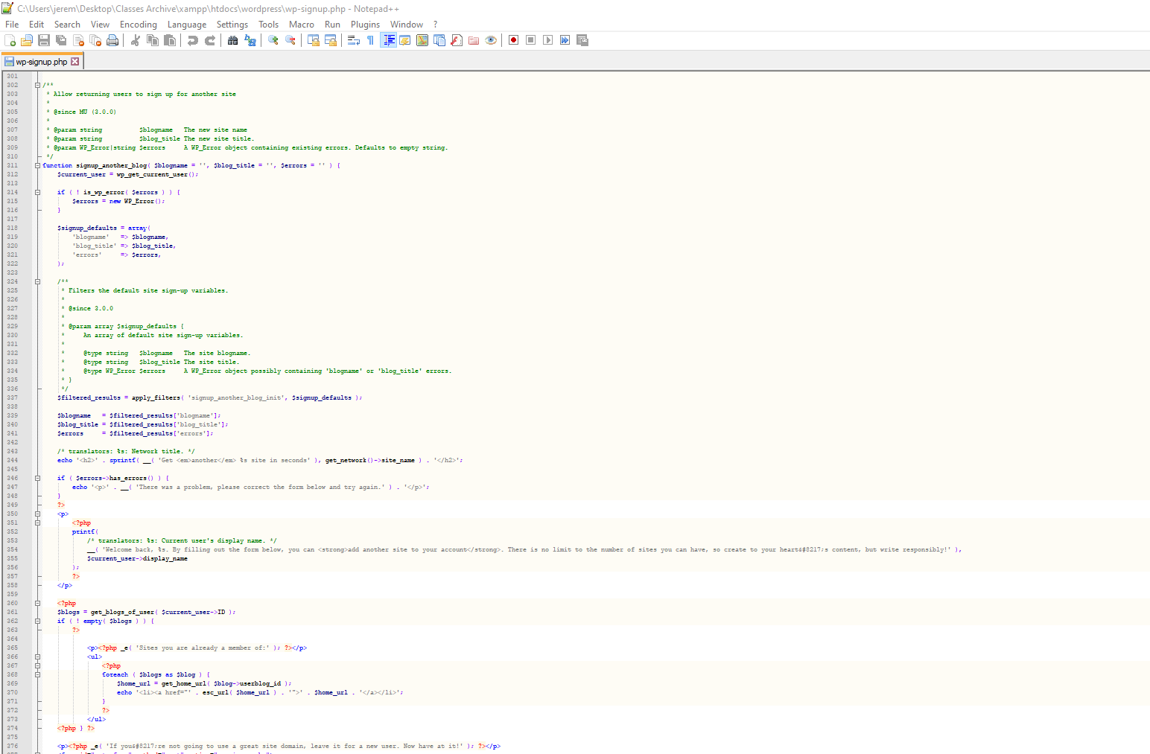

Figure 4.6 Registration PHP code 6

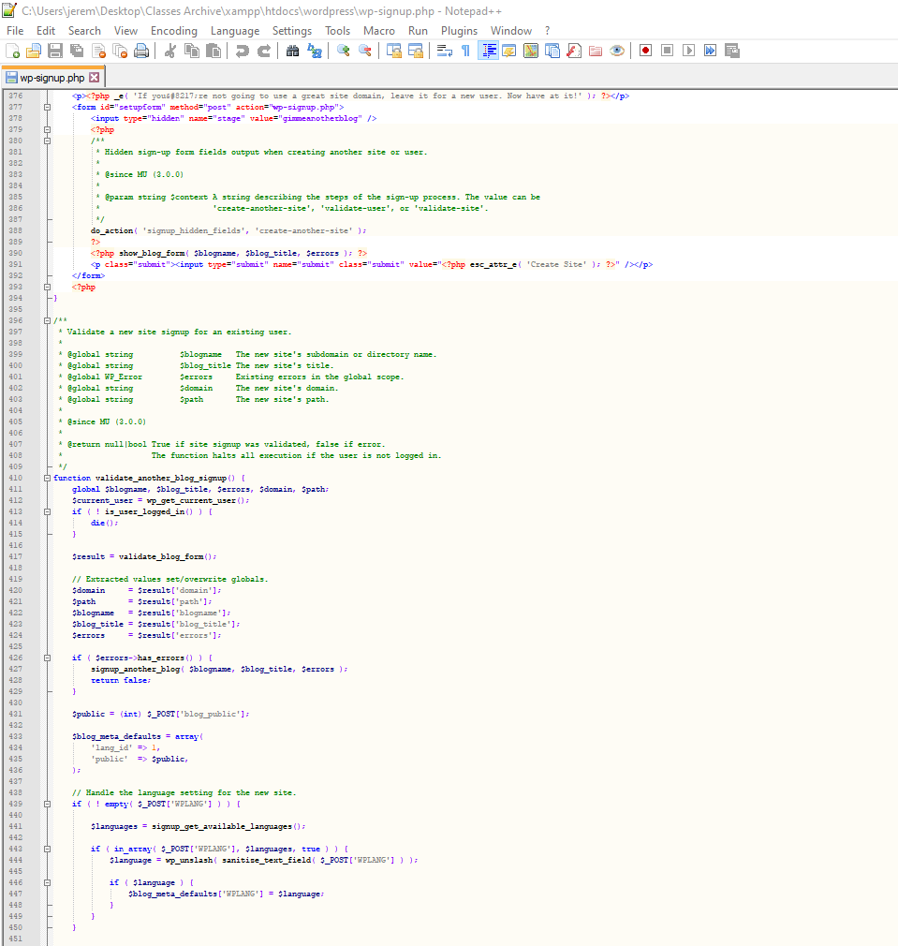

Figure 4.7 Registration PHP code 7

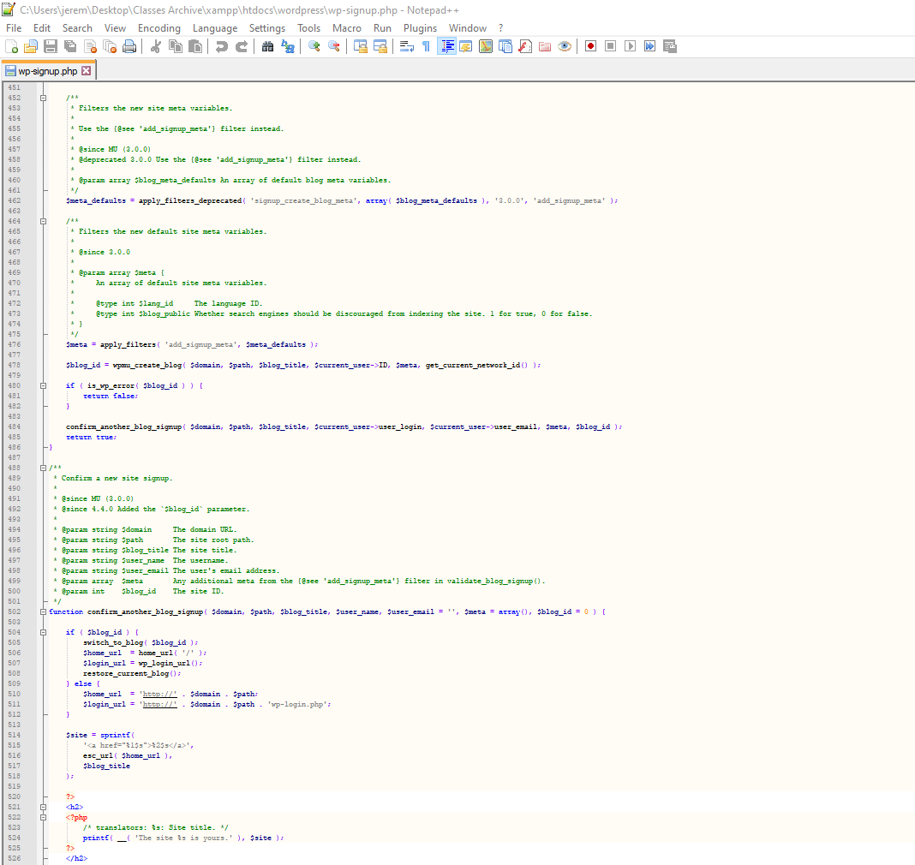

Figure 4.8 Registration PHP code 8

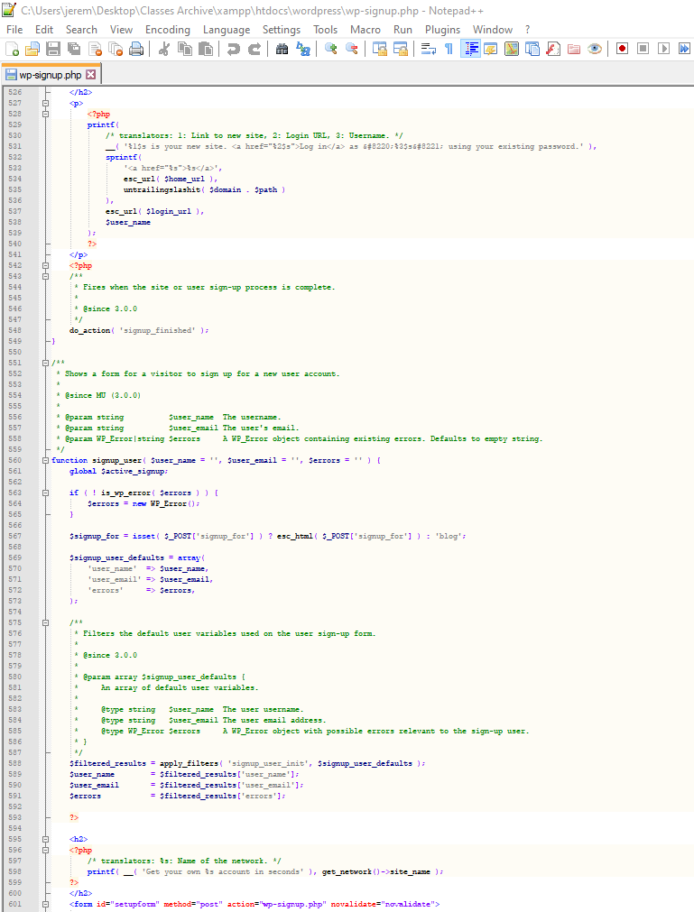

Figure 4.9 Registration PHP code 9

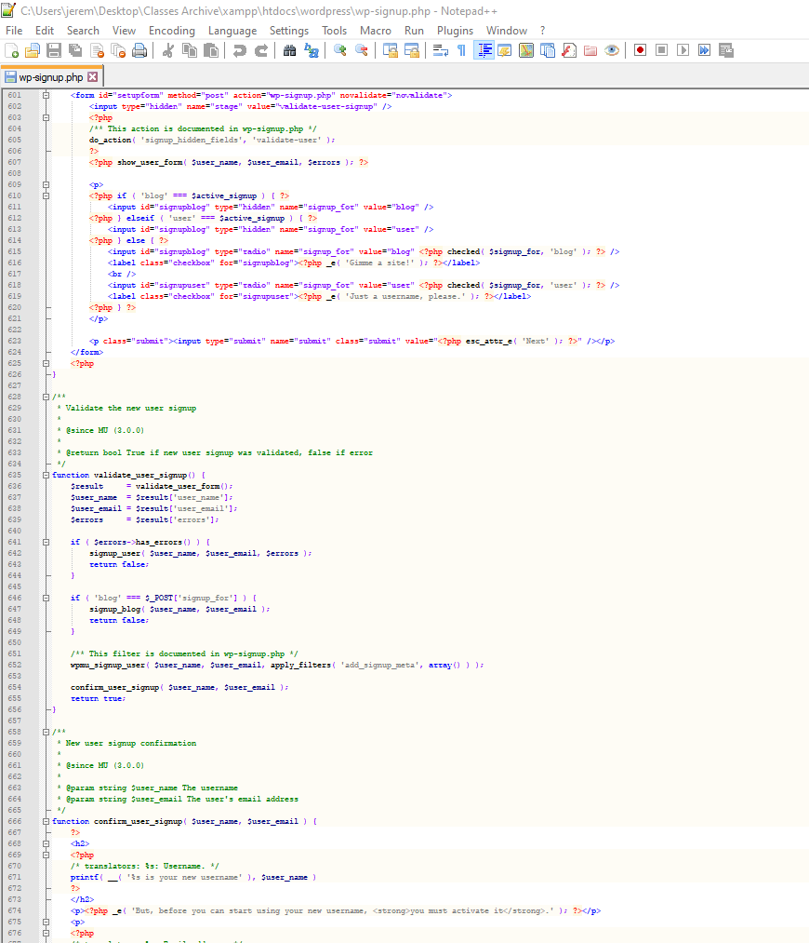

Figure 4.10 Registration PHP code 10

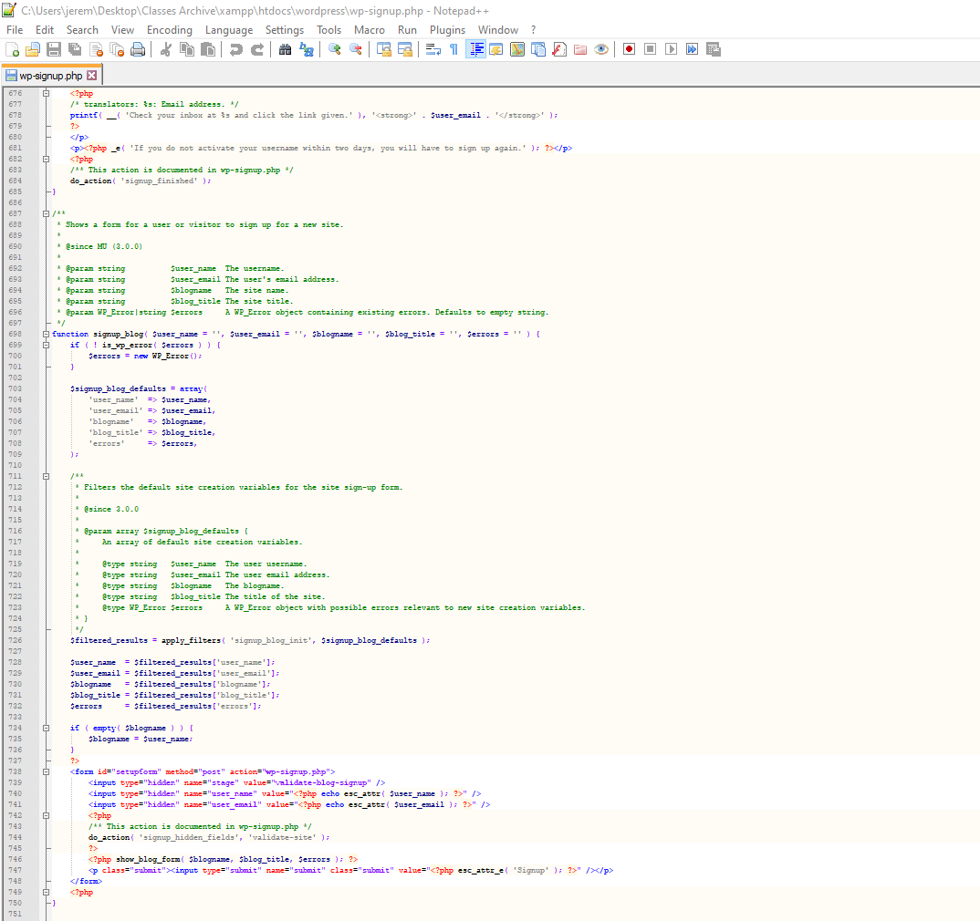

Figure 4.11 Registration PHP code 11

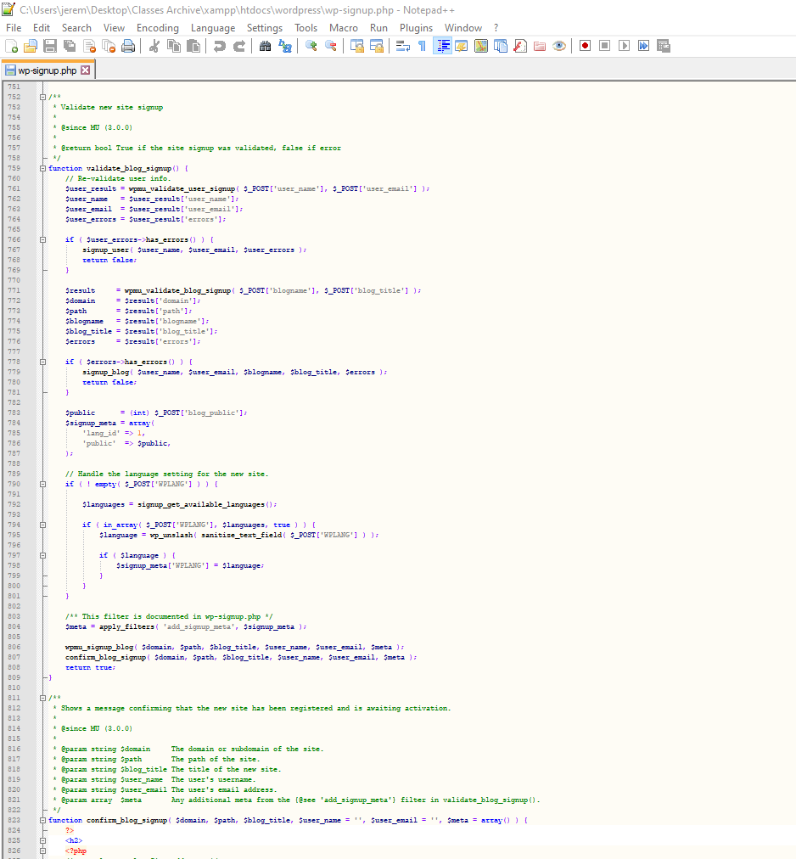

Figure 4.12 Registration PHP code 12

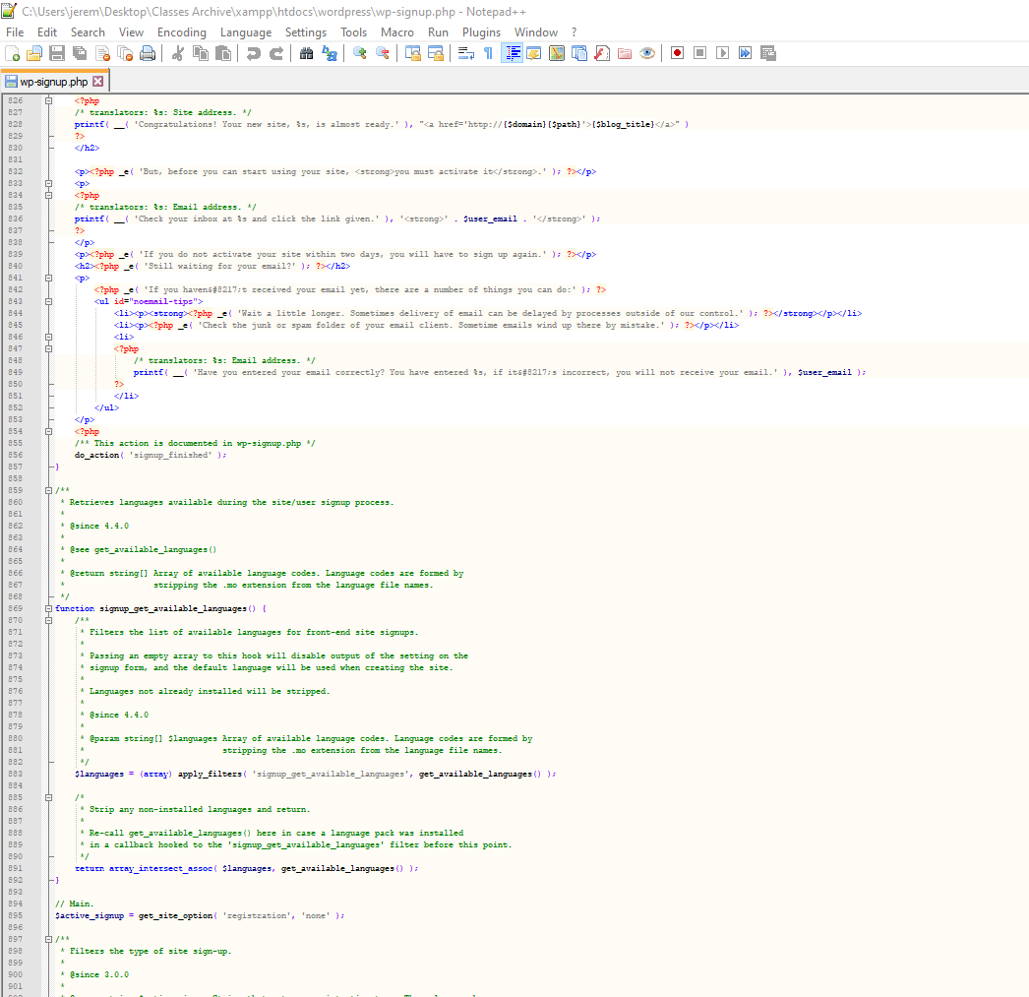

Figure 4.13 Registration PHP code 13

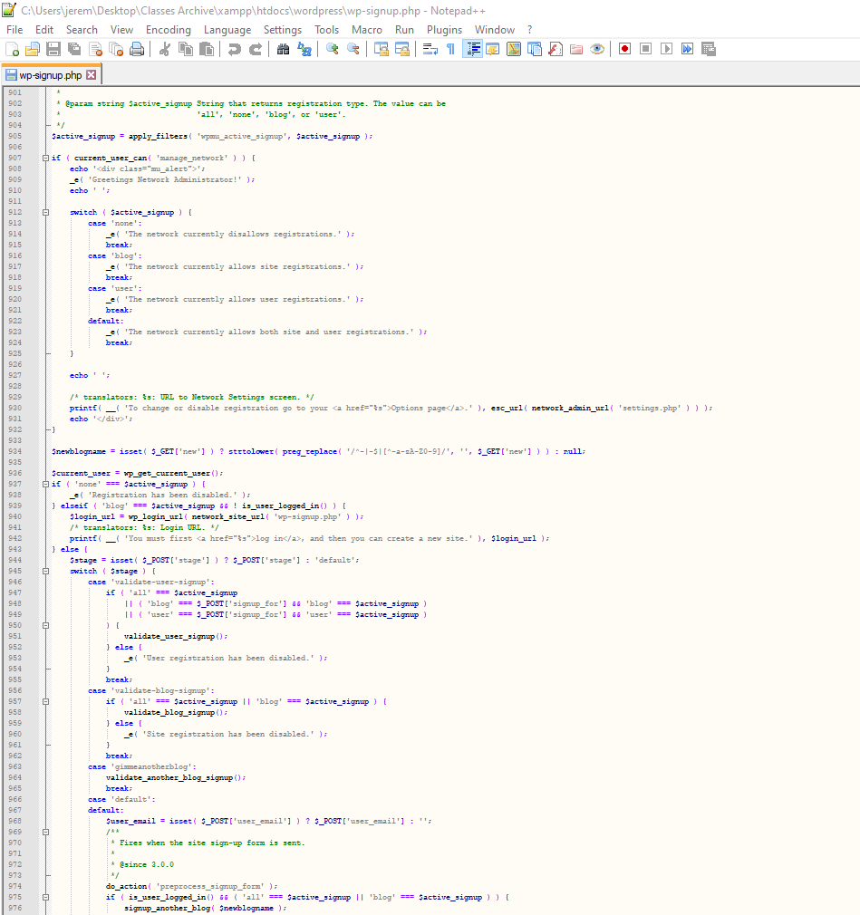

Figure 4.14 Registration PHP code 14

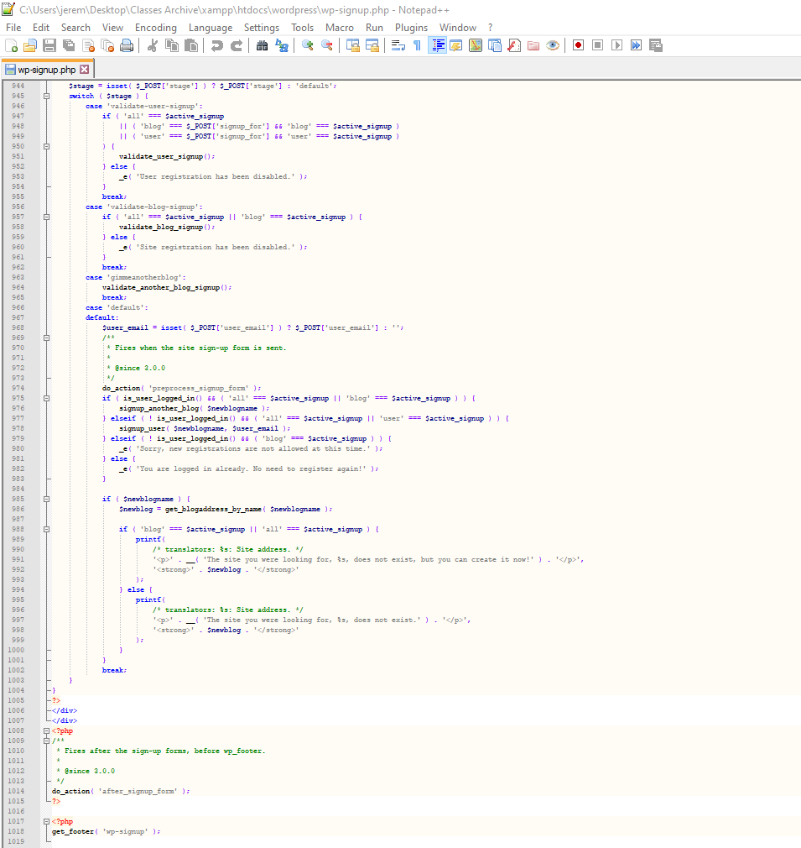

Figure 5.1 Elementor PHP Code 1

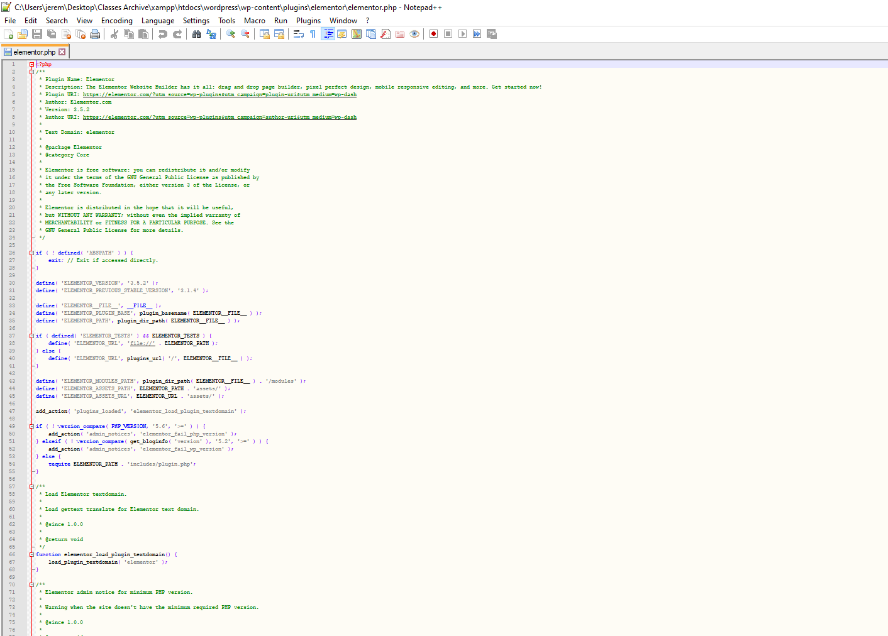

Figure 5.2 Elementor PHP Code 2

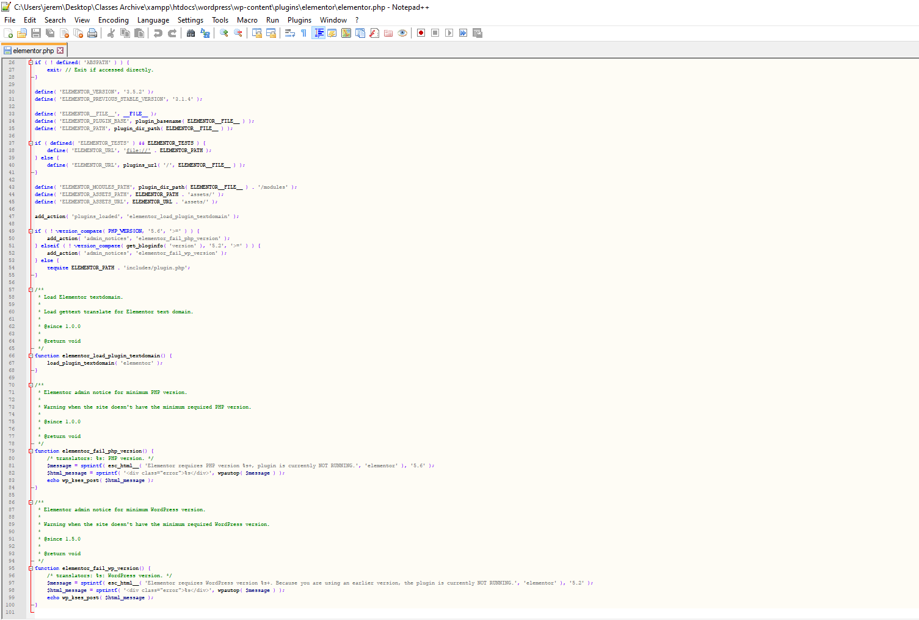

Figure 6.1 Forminator PHP Code 1

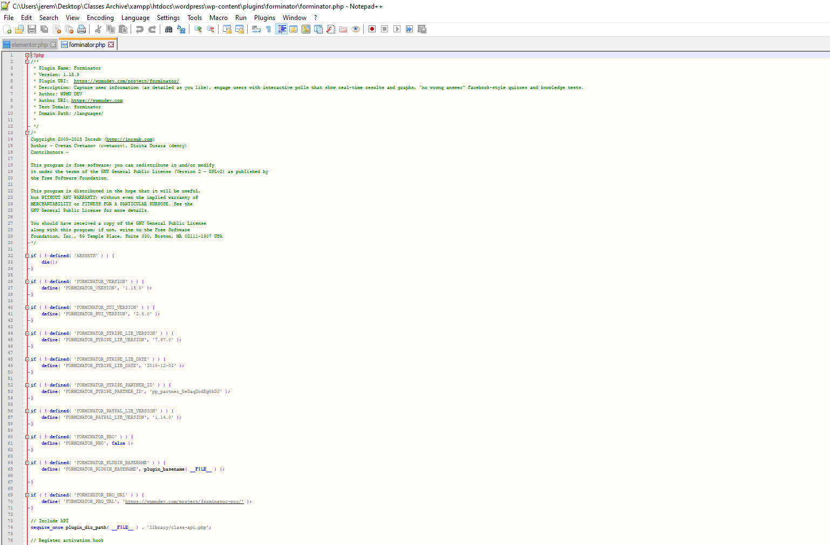

Figure 6.2 Forminator PHP Code 2

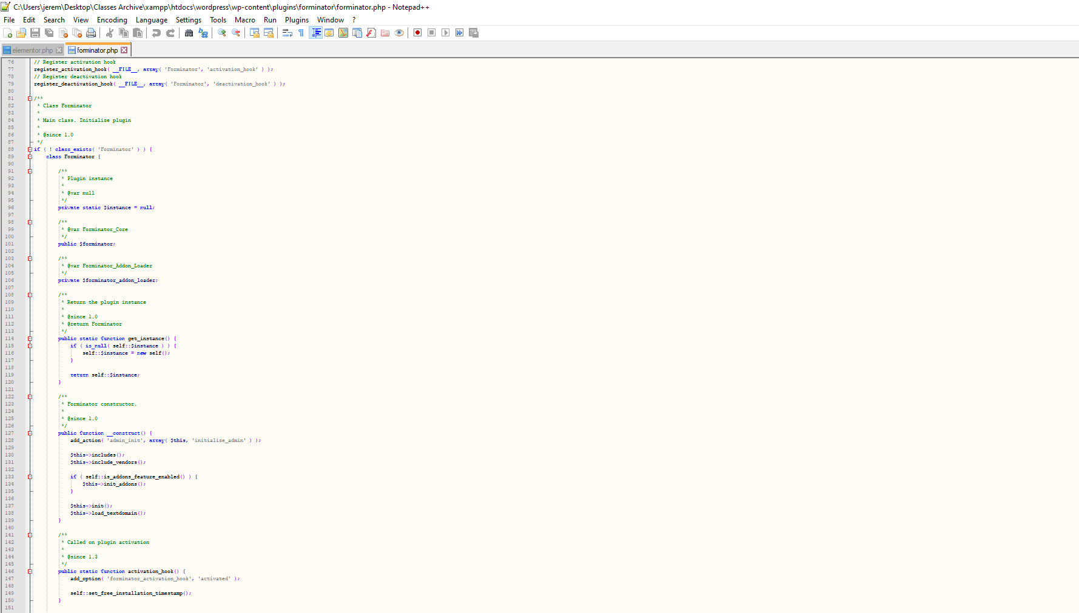

Figure 6.3 Forminator PHP Code 3

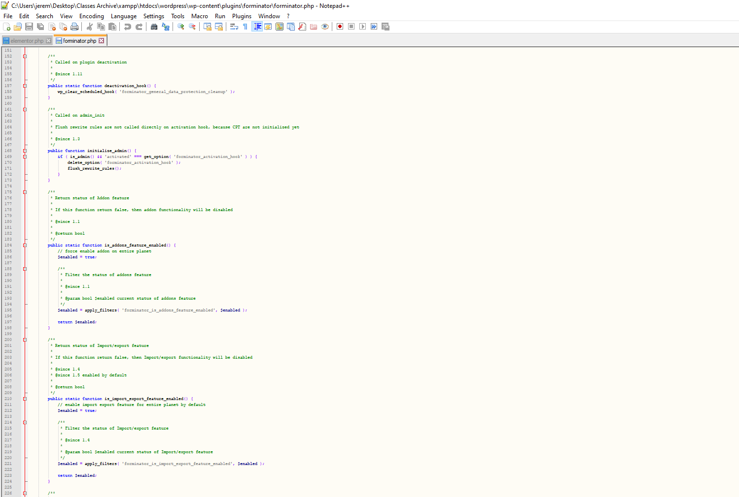

Figure 6.4 Forminator PHP Code 4

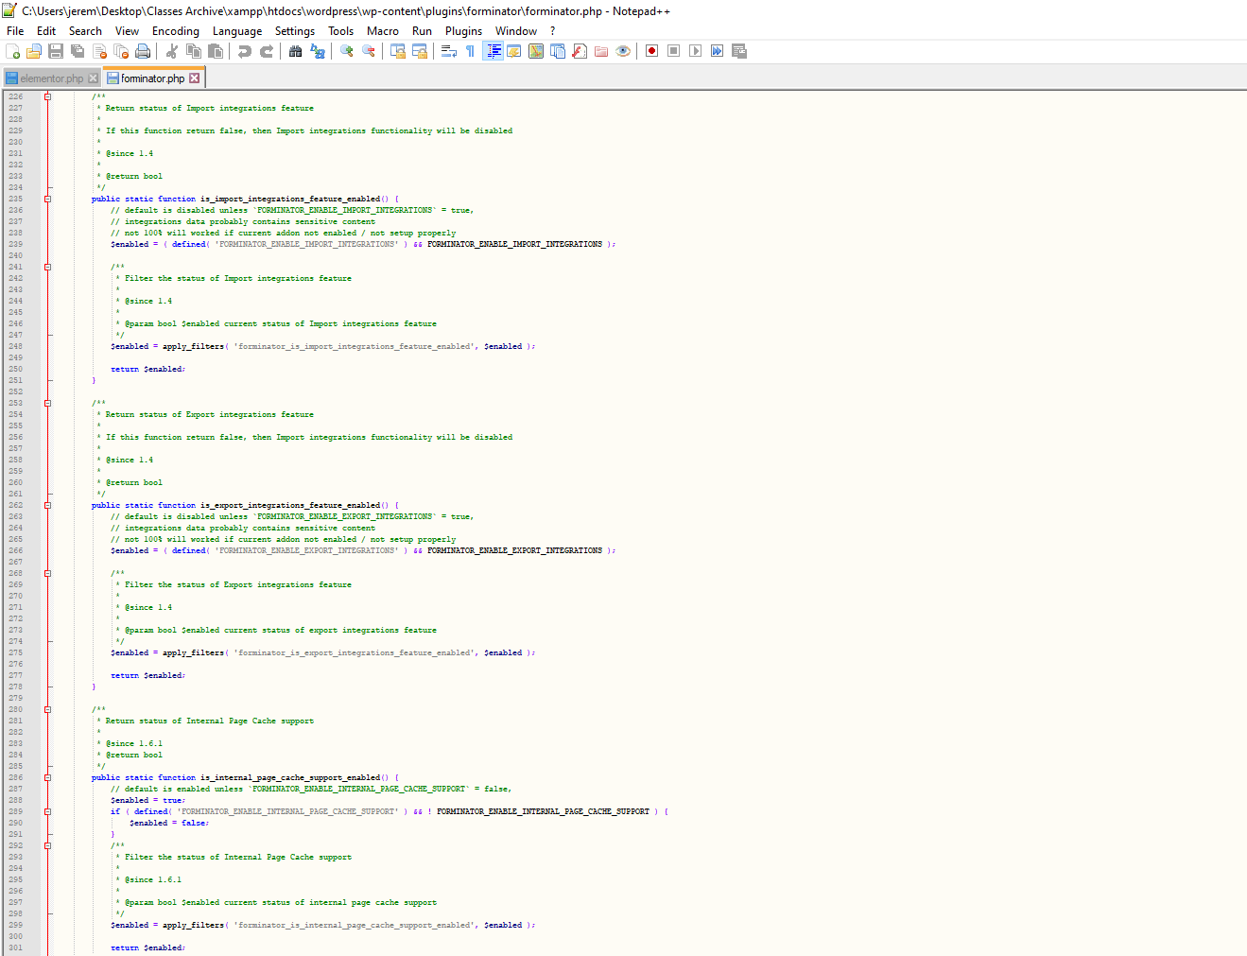

Figure 6.5 Forminator PHP Code 5

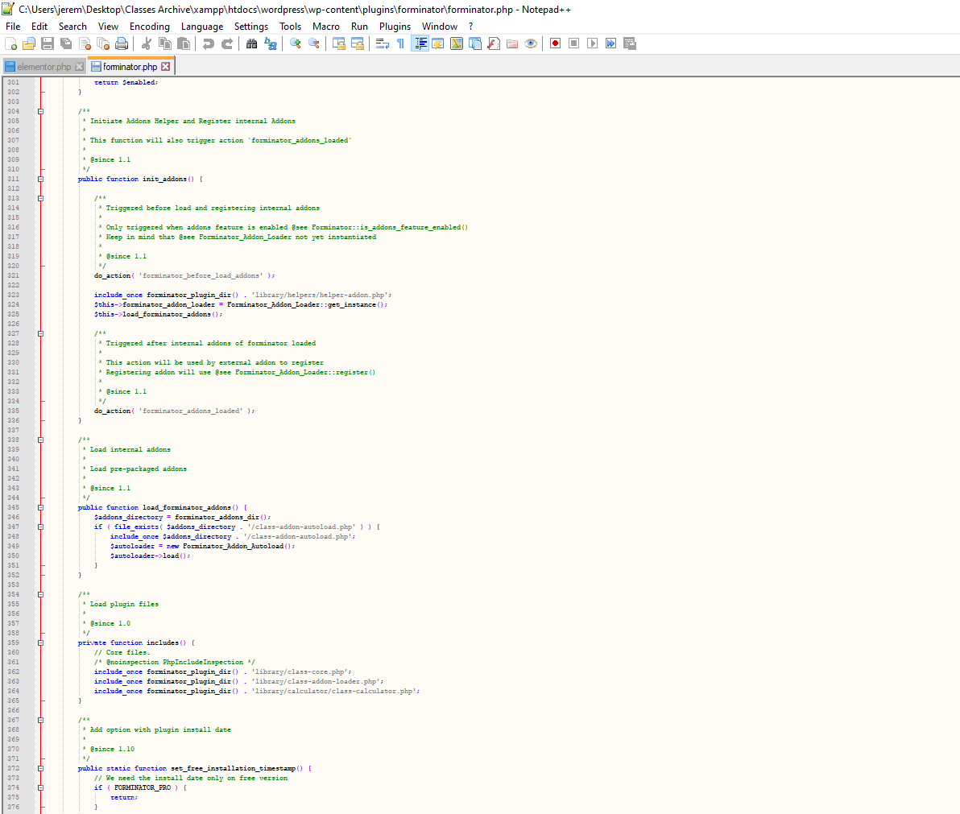

Figure 6.6 Forminator PHP Code 6



Figure 6.7 Forminator PHP Code 7

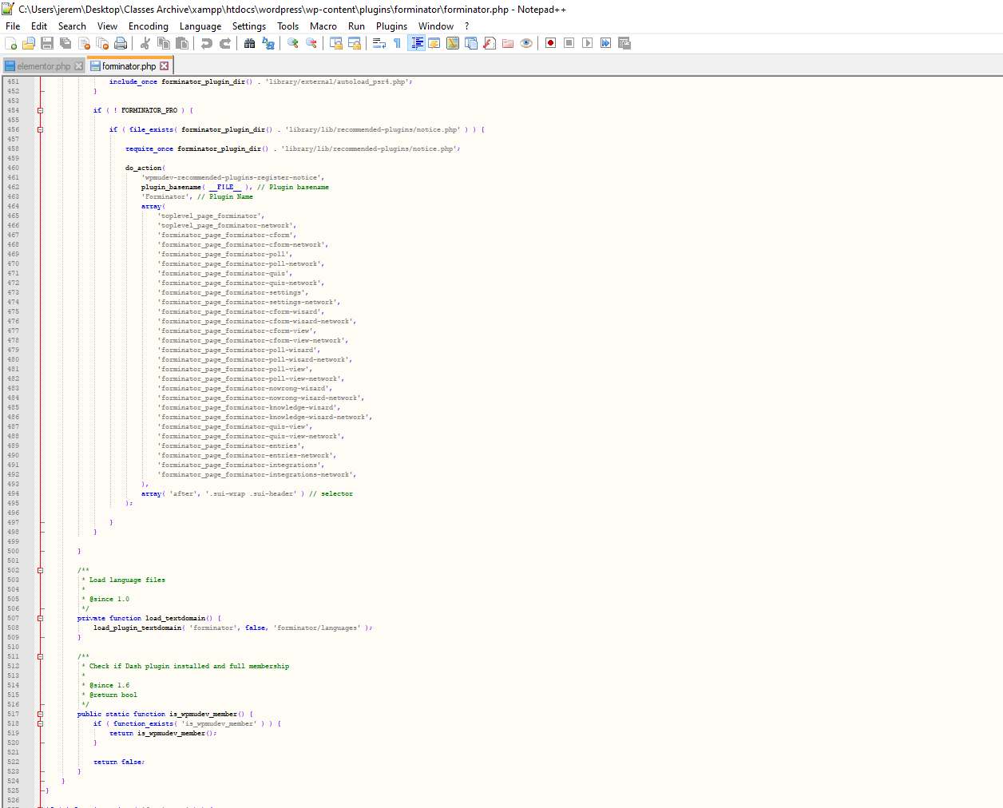

Figure 6.8 Forminator PHP Code 8

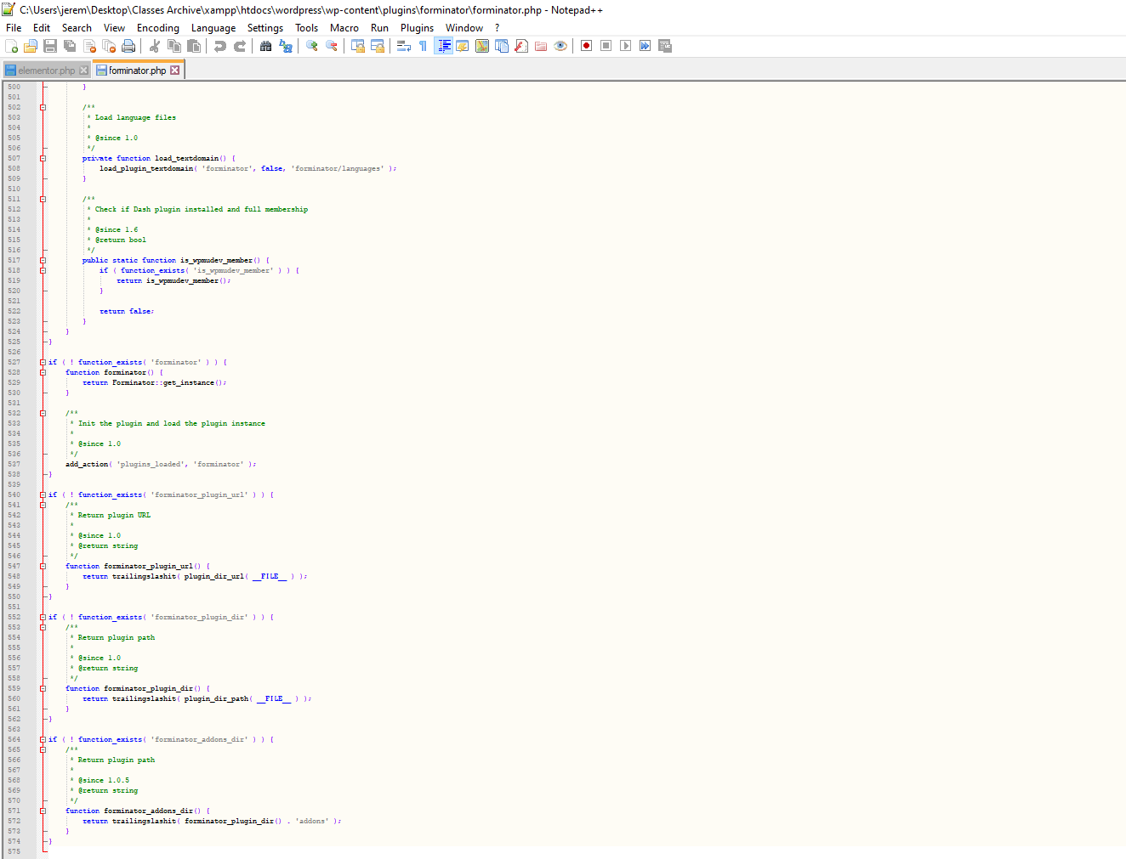

Figure 7.1 Profile Builder PHP Code 1

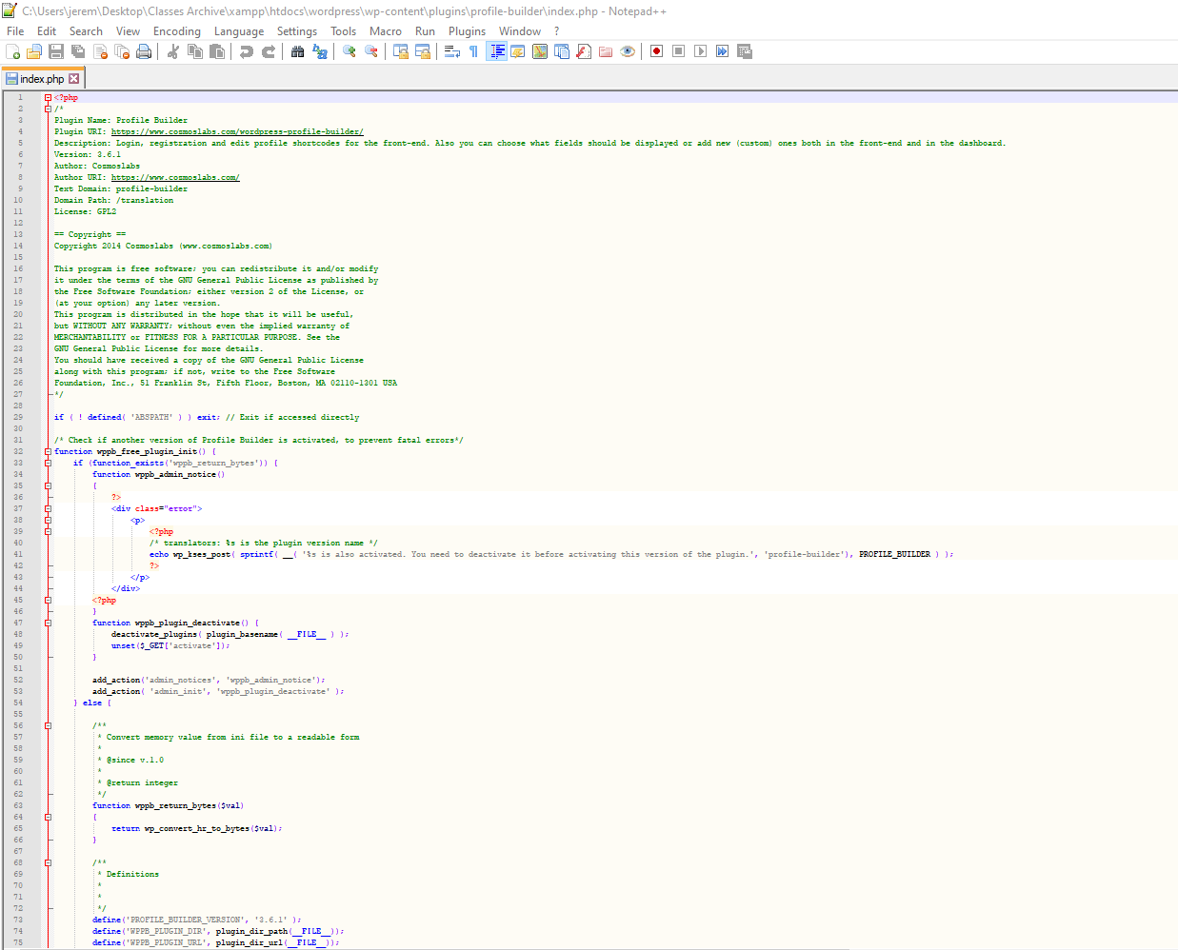

Figure 7.2 Profile Builder PHP Code 2

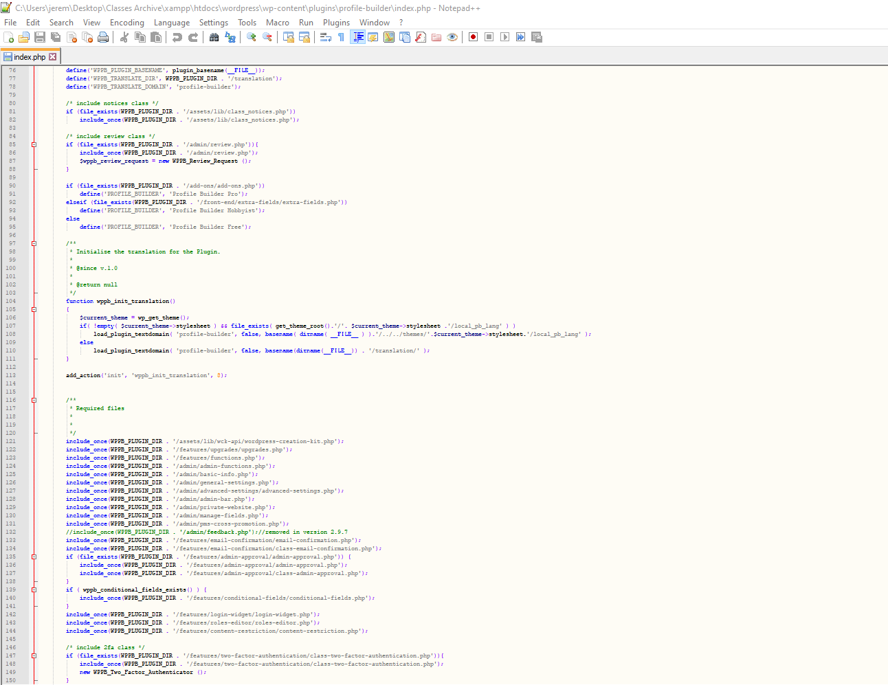

Figure 7.3 Profile Builder PHP Code 3

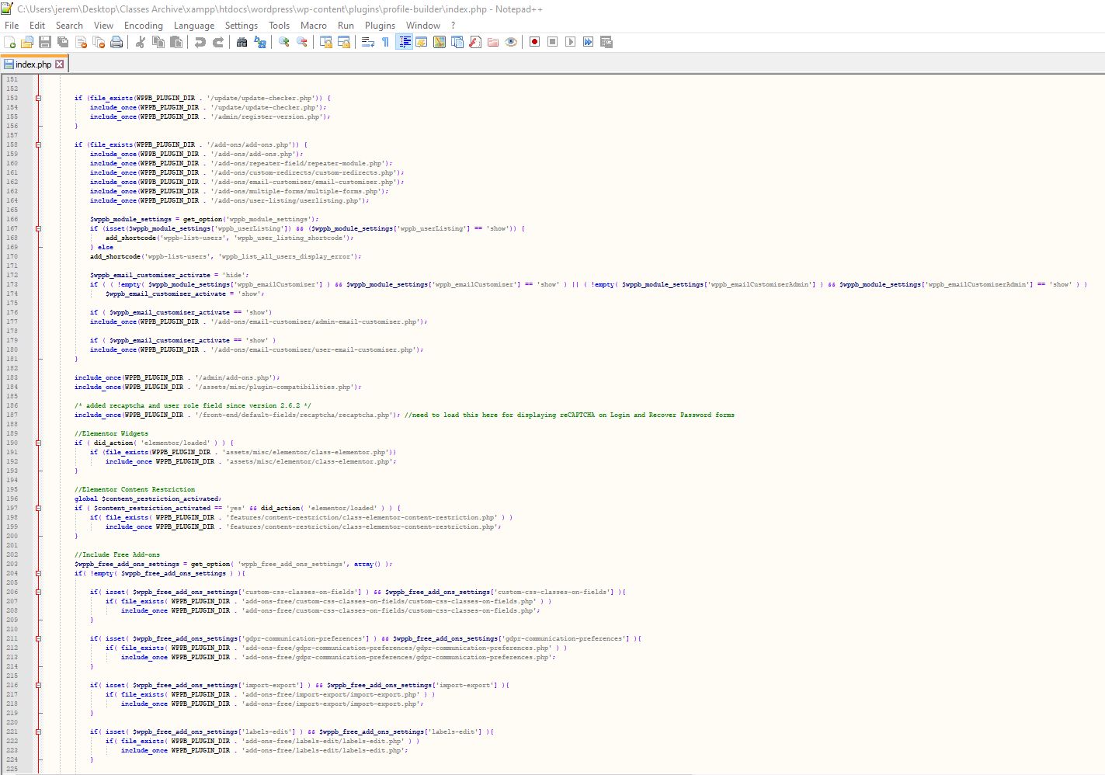

Figure 7.4 Profile Builder PHP Code 4

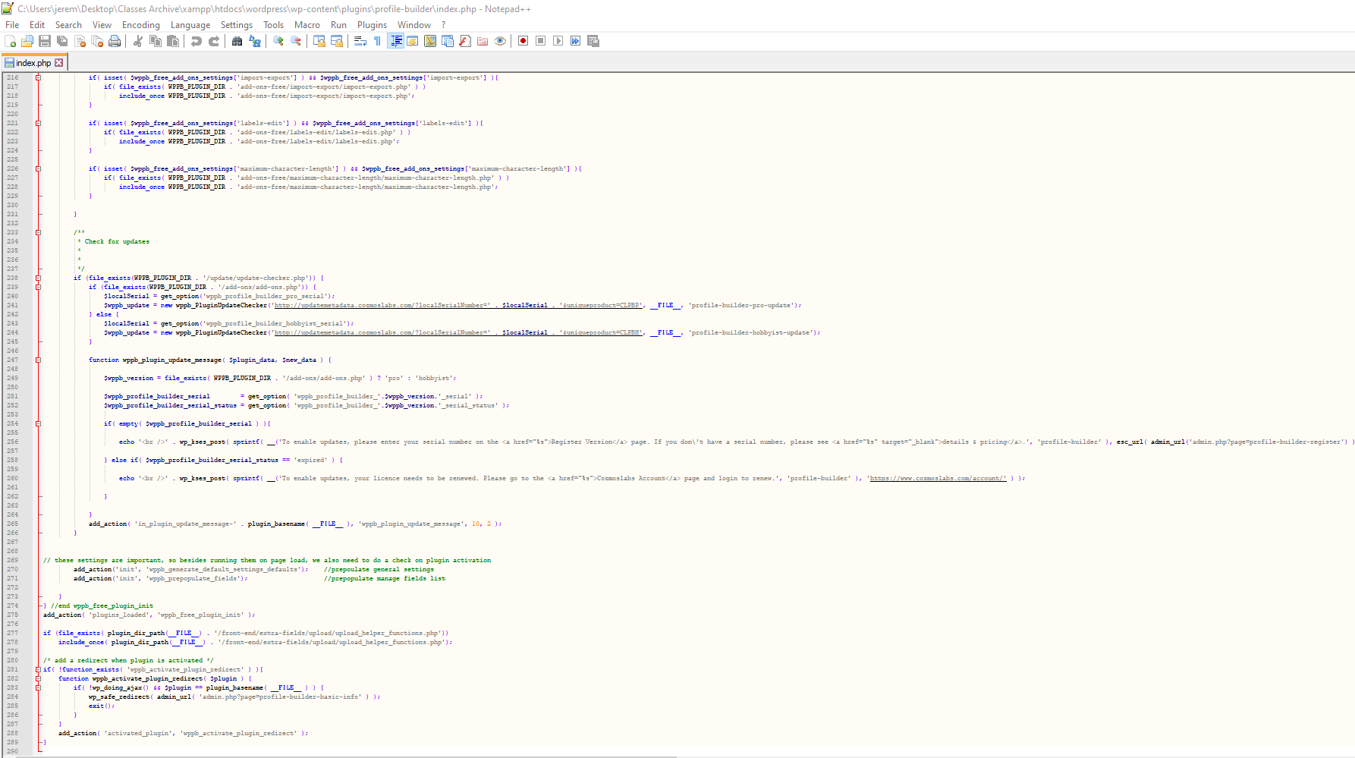

Figure 8.1 Sensei Index PHP Code 1

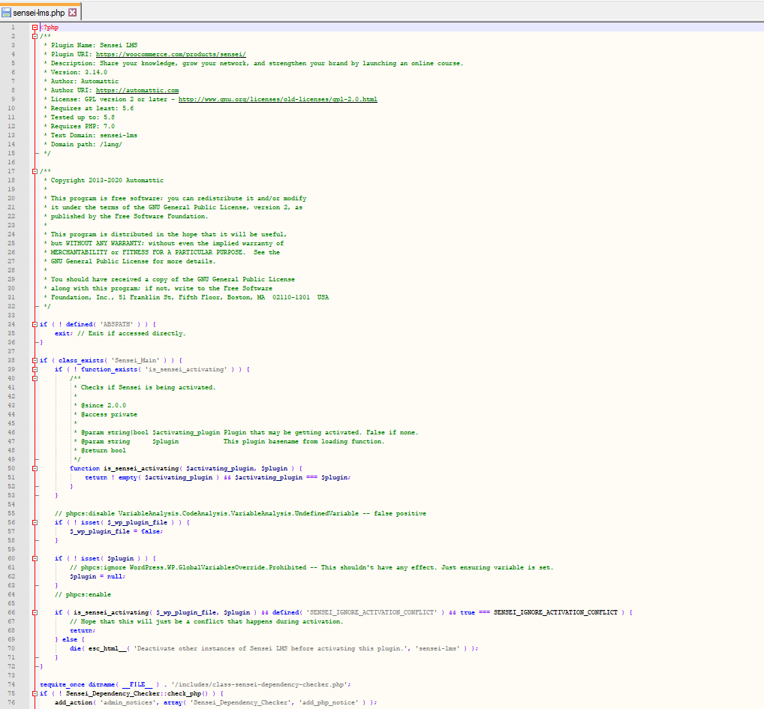

Figure 8.2 Sensei Index PHP Code 2

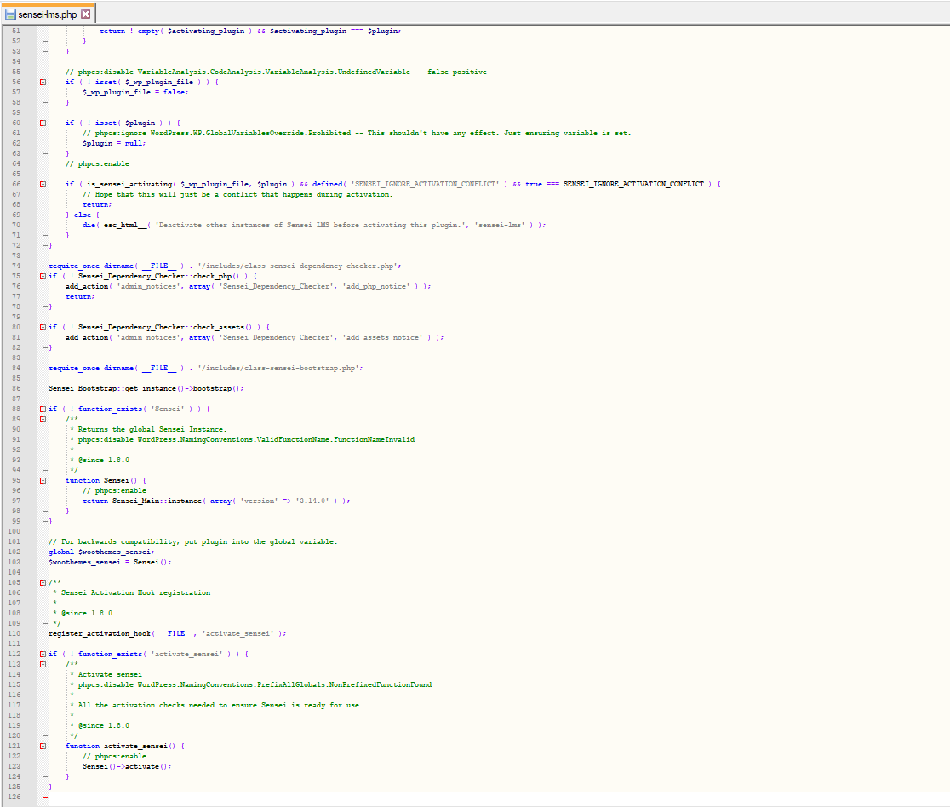

Figure 9.1 Learner Profile PHP Code 1

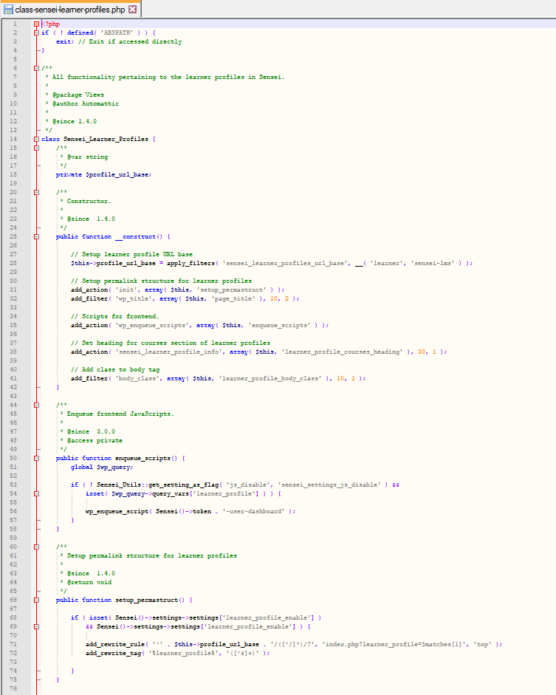

Figure 9.2 Learner Profile PHP Code 2

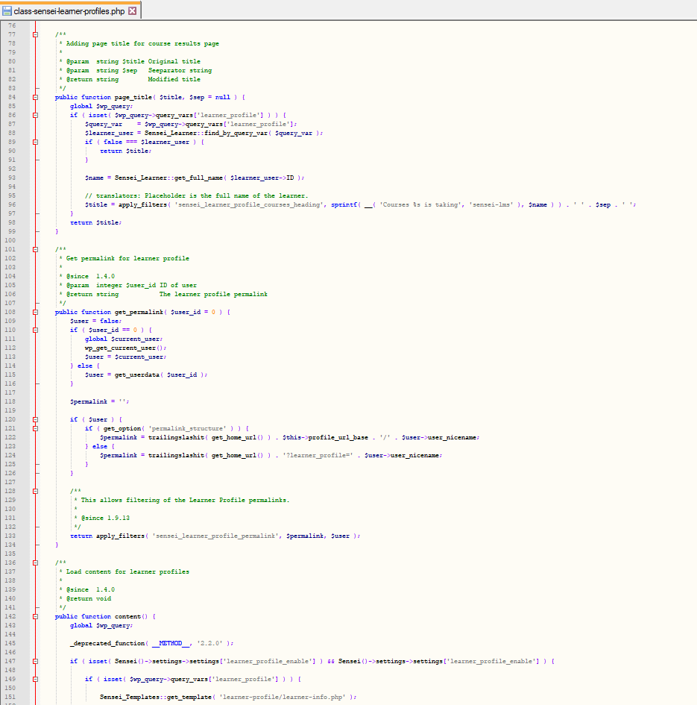

Figure 9.3 Learner Profile PHP Code 3

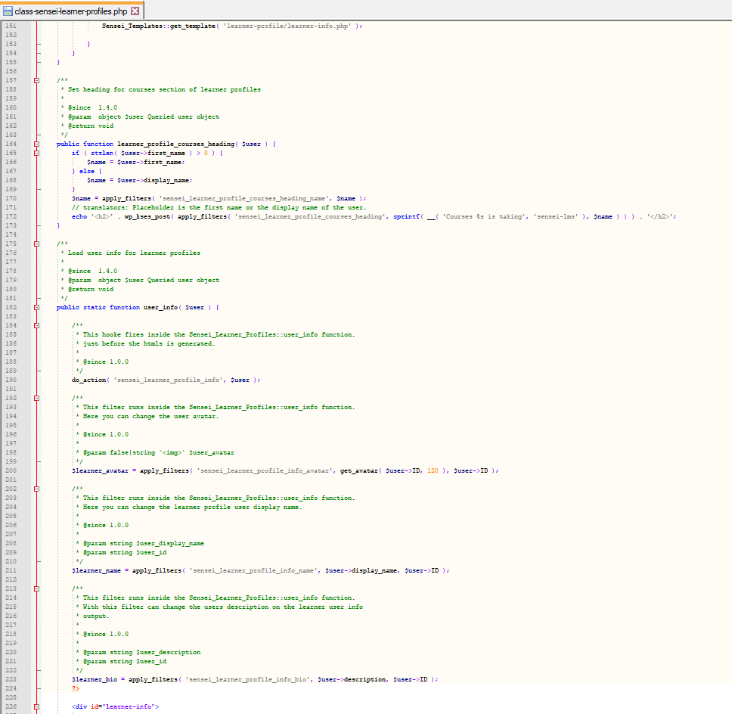

Figure 9.4 Learner Profile PHP Code 4

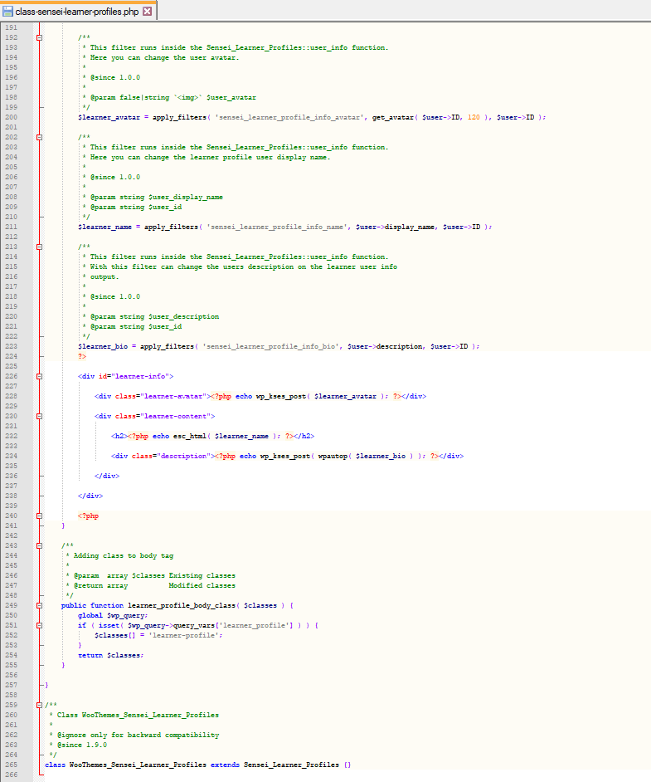

**References**

Agrona, C., (2018). Hooks: Actions and Filters - Sensei LMS. Sensei LMS. https://senseilms.com/documentation/hooks-actions-and-filters/

Roberts, T., (2017). How reusable is open source software? | 18F: Digital service delivery. Gsa.gov. https://18f.gsa.gov/2017/10/23/how-reusable-is-open-source-software/

Tsui, F., Karam, O., & Bernal, B. (2018). Essentials of software engineering (4th ed.). Jones & Bartlett Learning.

‌

‌

‌

‌

‌